Subjects
Functional overview

Subject records contain information about terms describing the principal themes, topical contents, and format characteristics of materials described in ArchivesSpace. Subject records are established and maintained separately in ArchivesSpace and are associated with accession, resource, resource component, digital object, and digital object component records by linking.

Subject terms function most effectively in ArchivesSpace when derived from broadly shared standard thesauri or controlled vocabularies such as the Library of Congress Subject Headings (LCSH) or the Art and Architecture Thesaurus (AAT). When creating subject records, ArchivesSpace users should adhere closely to the rules and standards associated with the specific controlled vocabulary, thesaurus, or authority file from which subject terms have been derived.

Subject records are not used to record information about the proper names of persons, corporate entities, or families functioning as subjects of materials described in ArchivesSpace. Information for these entities, and for software, is recorded and managed in Agent records.

Subject records support simple or compound hierarchical subjects (e.g., a topical heading subdivided by geographical and chronological subheadings). A subject record can be applied at any level of description for accessions, resources, and digital objects.

Note: Subject records linked to Accession records, Resource component records, and Digital Object component records will not be exported to MARCXML records. They will export for EAD files. The same is true for Agent records.

Search for a Subject Record

The search box on the main toolbar performs a keyword search across all fields and record types, i.e. Agents, Accessions, Resources, Subjects, etc.

- On the main toolbar, type your search query into the Search box. ArchivesSpace will display all the results for your search.

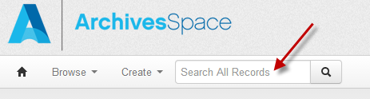

- You can perform the following operations to select a particular record from the list of search results.

- Narrow the list of retrieved records: Click on the available filters on the left side of the records list. Examples: Record Type, Creator, or Subject.

Example:

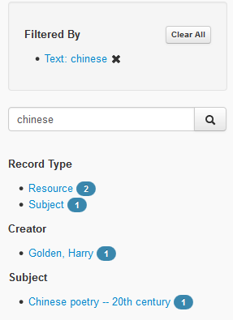

- Sort the list of retrieved records: Click on the desired sort order in the Sort by dropdown menu in the top right corner of the records list display. Subject records may be sorted by Relevance, Title, Date Created, Date Modified, and Record Type.

Browse for an Subject Record

The browse search on the main toolbar performs a search by record type and displays the results in the order selected in the Sort by box in the top right corner of the result display.
- On the main toolbar, click Browse and select Subjects. A listing of all the subject records in the repository will display.

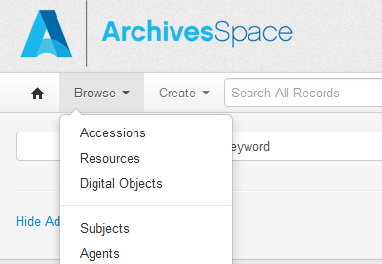

- You can perform the following operations to select a particular record from the list of subject records.

  - Narrow the list of retrieved records: Click on the available filters on the left side of the records list. Examples: Library of Congress Subject Headings, Local Sources, Topical, Geographic.

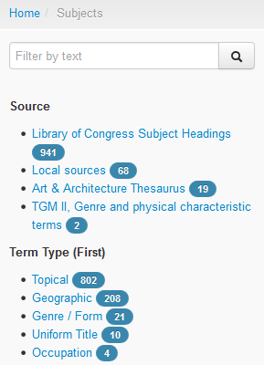

  - Sort the list of retrieved records: Click on the desired sort order in the Sort by and Select dropdown menus box in the top right corner of the records list display. Subject records may be sorted using the two dropdown menus by Terms Ascending, Terms Descending, Created Ascending, Created Descending, Modified Ascending, and Modified Descending.

View a Subject Record

Use Search or Browse to find the subject record you want to view. Click the View button on the right to see the record.

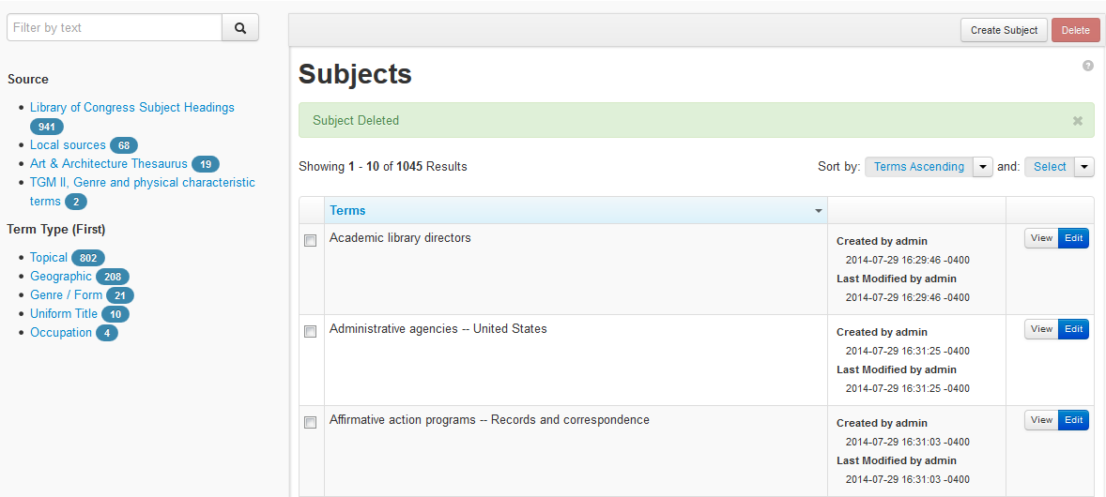

View a Subject Record in a New Window from Within an Accession, Resource, or Digital Object Record

This function enables a subject record to be opened in a new window from within an accession, resource, or digital object record and edited simultaneously.

- Navigate to the subjects sub-record of an accession, resource, or digital object record. Place your cursor over the subject highlighted in blue and click on it. A small View button will appear.

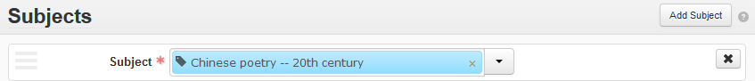
- Click the View button. The subject record will open in a new window.

Edit a Subject Record

- On the main toolbar, click Browse and select Subject. Search and filter to find and select the subject you wish to edit. Click the Edit button.

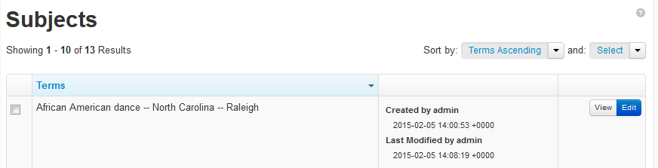
- Make any desired changes to the subject record, and then click Save. The green bar on the screen will indicate that the record has been saved.

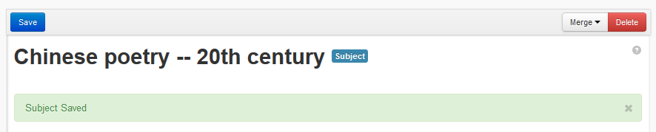
If the subject is missing any required fields, you will be prompted to complete the field(s) before saving the record.
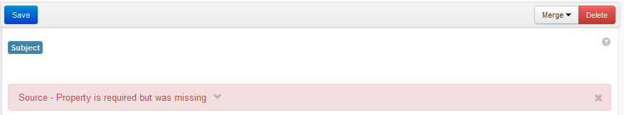
Subject Record Toolbar Functions

A subject record has a unique toolbar with several features that will display depending on your login permissions and installation setup. The features you may see include: Save, Merge, And Delete.

Save: The blue save button at the left of the bar is one of three ways to save a record. The others are the Save Subject button in the navigation bar on the left and the Save Subject button at the very bottom of the subject record.

Merge: The Merge feature collapses two or more separate subject records into one record. See Merge Subject Records for more information about this feature.

Delete: The Delete button deletes the entire subject record from the database.

Save a Subject Record
There are three ways to save a subject record when you are in the edit view.
- The Save button located at the top of the subject record under the main tool bar.

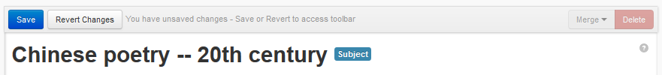
- The Save Subject button located at the bottom of the left navigation window.

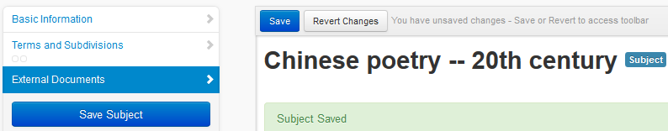
- The Save Subject button located at the bottom of the subject record.

In this document, the term “Save” will be used to mean any of these three methods of saving a record.
Merge Subject Records

Merging subject records may be appropriate when a repository has been using two or more subject terms with only slight differences for the same topic and wishes to simplify usage by consolidating the terms into a single preferred term. The Merge function is also useful for cleaning up imported subject records and for performing subject record maintenance occasioned by updates to subject terms by the Library of Congress and other sources of controlled vocabularies.

Note that merging subject records involves the permanent deletion of the subject record that is merged into another record. Any records that had been linked to the deleted subject record will now be linked to the merged subject record. This action cannot be reversed.

- Browse or search for the record for the subject you would like to merge with other subject records. Click Edit or View at the far right of the subject record in the results list.

Caution: The record you are searching for in this step is the record you would like to preserve in the database. The record(s) you would like to merge with this record and then delete is searched for in step 2 below.

- Click the Merge dropdown menu at the upper right corner of the subject record and type the first few letters of the subject you would like to merge with the subject represented by the current record. Matches will appear in pale blue. Click the term you wish to merge and then click Merge.

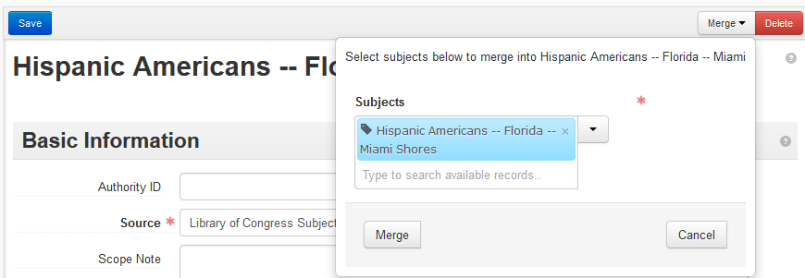

- A pop-up box will appear asking you to confirm your choice to merge the two records. Click Merge.

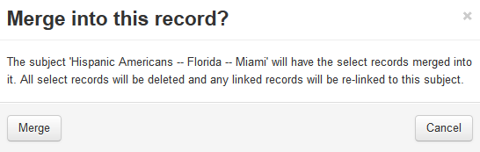

An alternative method of merging subject records involves using a browse search to find the subject record that will be merged.

- While inside the subject record with which you would like to merge other subject records, click the dropdown menu arrow next to the Subject and choose Browse.

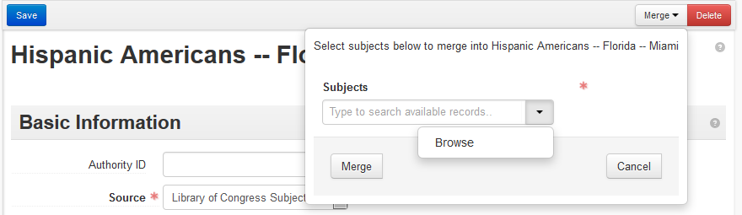

- In the pop-up box that will appear, browse for the subject that you wish to merge with the subject represented by the current record. Check the radio button to the left of the record in the results list. Then click Link to Subjects.

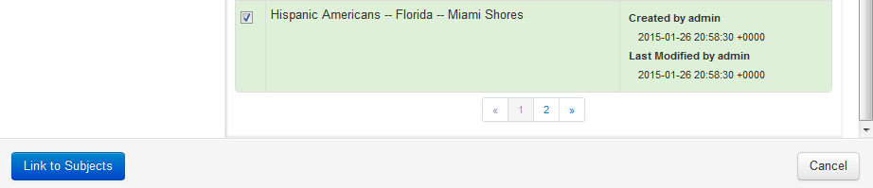

- When the correct subject record has been selected, click Merge.

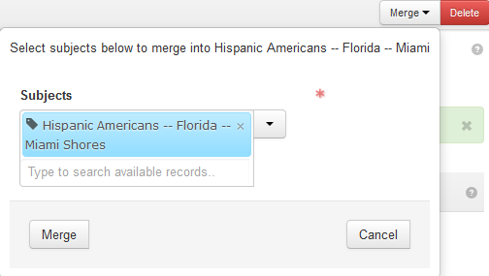

- A pop-up box will ask you to confirm whether you wish to merge the records. Click Merge, or click Cancel if you wish to abort the merge.

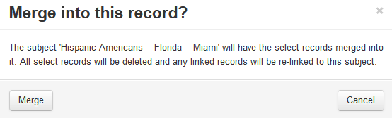

Delete Part of a Subject Record

- Use Search or Browse to find the subject record you want to edit.

- Click the Edit button at the right side of the appropriate record in the results list.

- When the record opens, click the sub-record of the record you wish to delete on the left navigation bar.

- At the top of the subjects sub-record form, click on the X in the upper right corner.

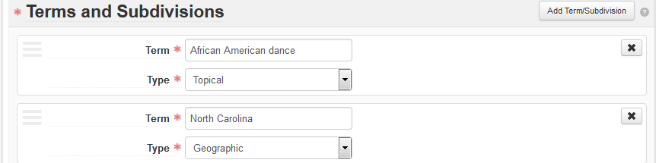

- Click the blue Confirm Removal button that will appear in the upper right corner of the section to delete the subject sub-record, or click Cancel to retain it.

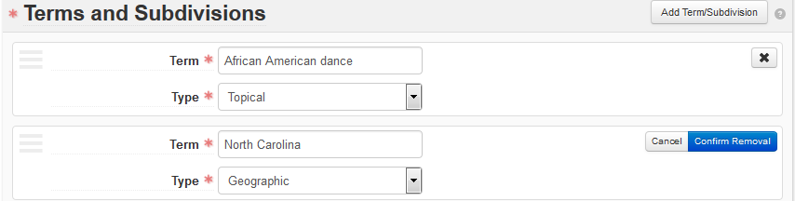

Delete an Entire Subject Record

Use Search or Browse to find the subject record you want to delete. If you use a browse search, you have two options for deleting a subject. If you use a keyword search (i.e., the search box), you will only be able to use option 2 (below) to delete a subject record.

- On the browse results screen, click the checkbox at the left of the record you wish to delete. Then click the red Delete button in the upper right corner.

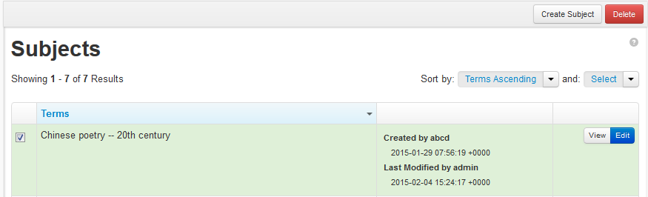

- On the results screen, click the Edit button to open the subject record in edit mode. Then click the red Delete button in the upper right-hand corner of the resource record.

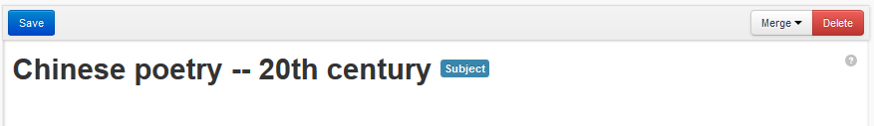

In each case, the system will warn you that you are permanently deleting the record. Click Delete again to continue, or click Cancel or X to exit the screen without deleting the record.

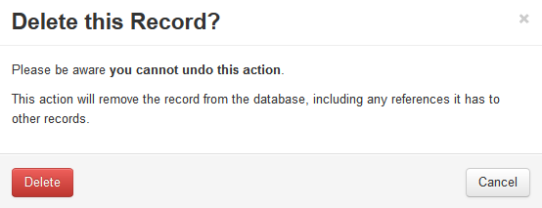

Link an Accession, Resource, or Digital Object Record to a Subject

- On the left navigation bar of the Accession, Resource, or Digital Object record, click Subjects. Then click Add Subject on the right-hand side of the Subjects sub-record.

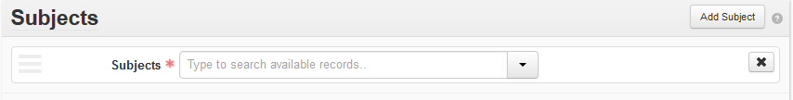

- Locate subject records by typing the first few letters of the subject term you are seeking directly into the empty subjects field. Click on the appropriate subject term from the pale blue list of subject matches that will appear. The subject term you select from the list will be inserted in the field. Multiple subject terms can be selected at this step. Click Save when you are finished adding subjects. Click Save when you are finished adding subjects.

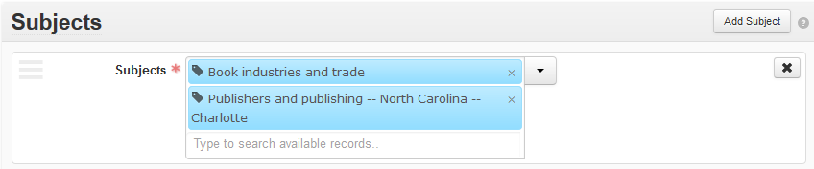

Alternative methods of linking to subject records involve browsing the database for records or creating a new subject record if the desired record does not yet exist in the database.

- Click on the dropdown menu arrow beside the Subjects field and choose Browse or Create.

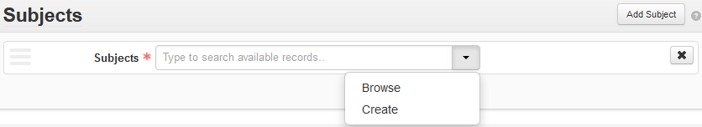

- The Browse command will cause a pop-up box to appear with a list of all the subject records available in your ArchivesSpace instance. The default order is alphabetical by title, but the two Sort By dropdown menus at the top right-hand corner of the box enable agents to be sorted using two criteria simultaneously—ascending or descending title, ascending or descending creation date, ascending or descending modified date

- To select a subject to link to the accession, resource, or digital object record, click on the radio button to the left of the subject record in the list. Then click Link to Subjects at the bottom of the pop-up box.

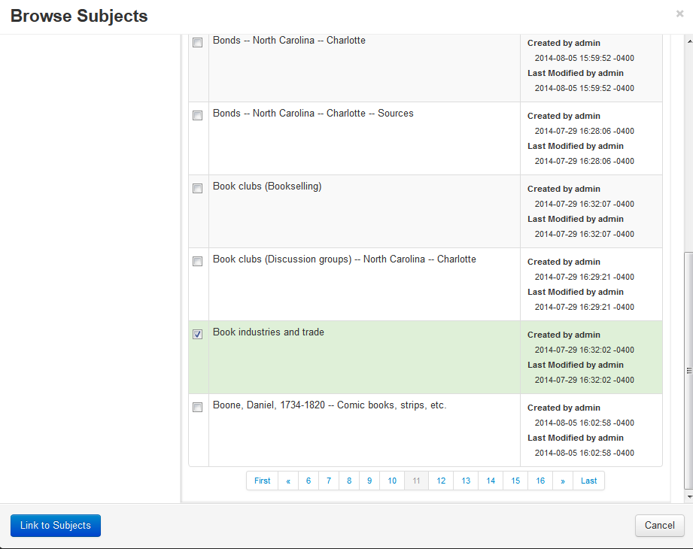

- When you have linked the desired subject term, Save the record.

- Choose Create from the subjects dropdown menu if no subject record is available for the subject you wish to link. Follow the instructions in Create a New Subject.

Remove a Subject Link from an Accession, Resource, or Digital Object Record

Use Search or Browse to find the accession, resource, or digital object that contains the subject link you wish to delete.

- Click the Edit button at the right-hand side of the desired record in the results list.

- When the record opens, click Subjects on the navigation bar at the left of the screen to navigate to the subject sub-record(s).

- Click on the X in the right corner of the subject link you wish to delete.
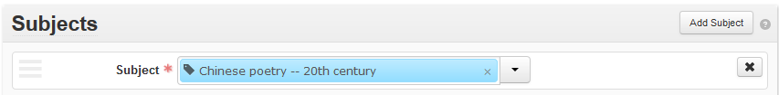

- Click the blue Confirm Removal button that will appear in the upper right corner of the section to delete it, or Cancel to retain it.
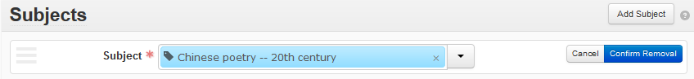

Import Subject Records in a MARCXML File

Subject records from an external source (e.g., the OCLC Connexion authorities file) may be imported into ArchivesSpace in a MARCXML file.

- Save the MARCXML file you have created from an external source to your desktop.

- On the Repository dropdown menu at the right of the ArchivesSpace homepage, select Import Jobs.

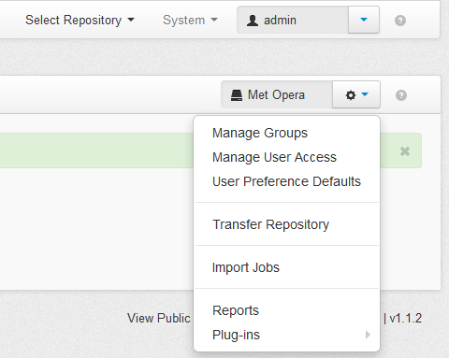

- Click the Create Import Job at the top right of the Import Jobs page.

- Click the arrow at the right of the Import Type dropdown list and choose MARCXML (Subjects and Agents Only). Then click Add File.

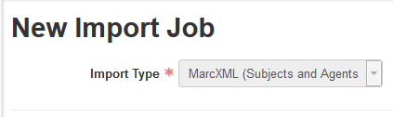

- Open the MARCXML file to be imported on your desktop. The name of the file will appear beneath the green Add File button in ArchivesSpace. Click the blue Queue Import Job button below the name of the file to be imported.

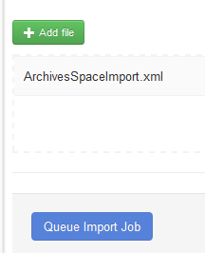

- ArchivesSpace will import the file, creating a log of import actions. When the file has been imported, a message indicating that the import job has completed will appear at the left of the screen.

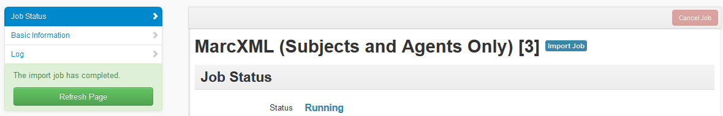

- MARCXML records imported from other sources are often minimal, meaning that they will include only the required fields. Such records can be enhanced with additional information after import if desired.

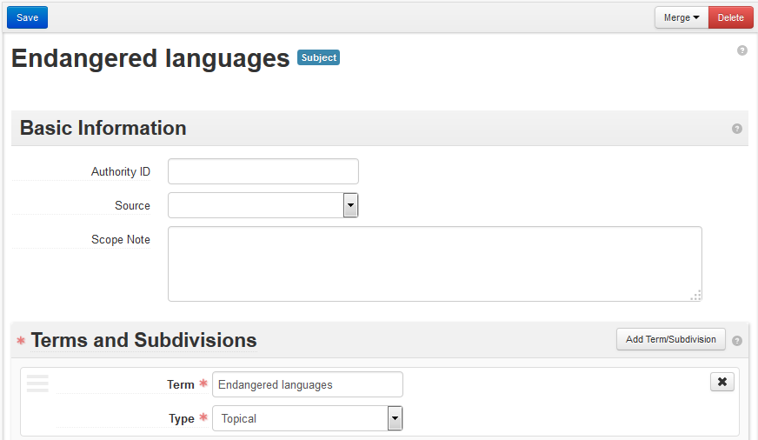
Imported subject record from OCLC authorities file lacks Authority ID, Source field information.

Create a New Subject Record

Subject records may be created from within an accession, resource record, or digital object record, or from the ArchivesSpace home page.

If you are already working in an accession, resource record, or digital object record:

- On the left navigation bar, click Subjects. The record to the right will scroll down to the Subjects section. Click Add Subject on the right-hand side of the Subjects bar. Then click the dropdown list button and select Create.

If you are starting from ArchivesSpace home:

- On the main toolbar, click Create and select Subject from the dropdown menu.

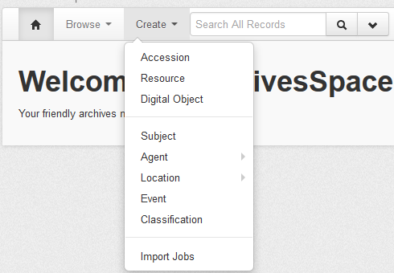

Subject Record Fields

Each subject record contains three sub-records: Basic Information, Terms and Subdivisions, and External Documents. The Basic Information and Terms and Subdivisions sub-records contain required fields that must be supplied in order for you to add the subject record to the database. These fields are indicated with red asterisks. The External Documents sub-record is not required in order to add a new subject record. However, if you choose to add this sub-record, you must supply the asterisked fields Title and Location.

A minimal subject record may be created by filling in only the required fields. The minimal record can be enhanced later with additional fields.

Required Elements: Source (Basic Information Sub-Record), Term and Type (Terms and Subdivisions Sub-Record)

Basic Information Sub-Record

The Basic Information sub-record contains information about the source and identifiers of controlled vocabulary terms recorded in subject records.

Fields:

- Authority ID (open text field): The unique identifier for the record within the source from which the term was acquired (e.g., an LCSH number, the ID number of a Getty Thesaurus of Geographic Names record, etc.). The identifier may be represented as a URI.

- Source (dropdown list): The controlled vocabulary or thesaurus from which an established term is derived. Source values assigned in this field are used as filters in the left-hand navigation pane in keyword and browse searches.

There are nine default Source values that may be assigned to subjects from the dropdown list:

Art and Architecture Thesaurus

Genre Terms: a Thesaurus for Use in Rare Book and Special Collections Cataloging

Getty Thesaurus of Geographic Names

Library of Congress Subject Headings

Local Sources

Medical Subject Headings

Source Not Specified

TGM II, Genre and Physical Characteristic Terms

The option Local Sources is available for cases in which the term used has not been derived from one of the thesauri or controlled vocabularies provided in the list and is maintained in a local list of preferred terms.

The Source values in the dropdown list can be customized to include values from other controlled vocabularies or sources with the Manage Controlled Value Lists function.

- Scope note (open text field): A note that explains and clarifies how and in what situations the term should be used and/or distinguishes it from similar terms.

Example:

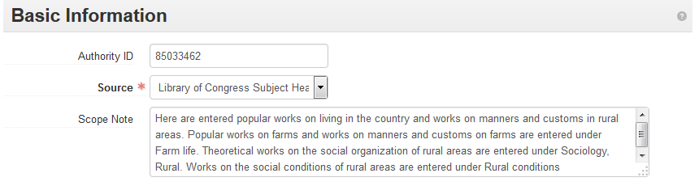

Terms and Subdivisions Sub-Record

The Terms and Subdivisions sub-record is mandatory. Two elements, Term and Type, must be supplied.

Fields:

- Term (open text field): The term for the subject. Each subject record must have at least one term associated with it.

If the term is compound or multipart in nature (e.g., an LCSH term accompanied by geographical, topical, or chronological subheadings), enter the primary term in this field and create additional term and type fields for the subsidiary element(s) of the term by clicking Add Term/Subdivision for each subsequent element. This command will cause new Term and Type fields to appear.

Example: African American dance -- North Carolina -- Raleigh

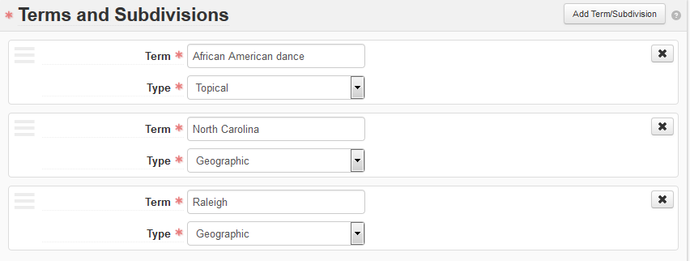

- Type (dropdown list): Indicates the type or category of the term being recorded. Type terms assigned in this field are used as filters in the left-hand navigation pane in keyword and browse searches for subjects.

There are ten values that can be assigned to subjects in ArchivesSpace from the Type dropdown list.

Cultural Context

Function

Genre/Form

Geographic

Occupation

Style/Period

Technique

Temporal

Topical

Uniform Title

Choose a type value from the dropdown list that accurately describes the scope and nature of the term applied and/or the controlled vocabulary from which it is derived.

Examples:

LCSH terms = Topical
LCSH geographical subheadings = Geographic
Basic Genre Terms for Cultural Heritage Materials (BGTCHM) = Genre/Form

External Documents Sub-Record

The External Documents sub-record creates links to external documentation that discusses how a particular subject record is to be used.

To add the external documents fields sub-record, click on the Add External Document button at the right of the sub-record.

Fields:

- Title (open text field): The title of an external document. The document may be of any form or content. Examples: A web accessible file, a network accessible file, a file on the same computer as the application, etc.

- Location (open text field): The location of the file, ideally a resolvable URI. Example: http://www.archivesspace.org/membershipfile:///c:/path/to/the%20file.txt

- Publish (check box): A selected check box indicates that this External Document should be published to the public interface. Since subjects do not yet have page-level views in the public interface, however, any external documents attached to a subject will only be visible in the staff interface.

Agent Records

Functional overview

Agent records identify persons, families, corporate entities, or software that have a specified relationship to archival materials or to an event. Agent records are also used to manage relationships among names. They are established and maintained separately in ArchivesSpace and may be associated with accession, resource, resource component, digital object, and digital object component records by linking.

There are four types of agent records in ArchivesSpace:

- Person

- Family

- Corporate entity

- Software

Each agent record type must be linked to materials descriptions as a creator, source, or subject.

- Creator designates the primary responsibility for the material being described. Creator can encompass, at various levels in a multilevel description, the person, family, or corporate entity responsible for the archival provenance of the material being described, or for the intellectual content of the same material.

- Source designates the immediate source of acquisition of the materials being described.

- Subject designates that the materials being described are topically about the named person, family, or corporate body or theme of the materials being described.

Agent records in ArchivesSpace are designed to conform with the International Council on Archives’ International Standard Archival Authority Record for Corporate Bodies, Persons, and Families, 2nd edition (ISAAR(CPF)). They are also designed to support output in the Encoded Archival Context--Corporate Bodies, Persons, and Families (EAC-CPF) data structure and interchange standard. If an authority record cannot be located and copied from an authorities database, agent records also accommodate the creation of names according to data content rules established in standards such as Resource Description and Access (RDA) and DACS. ArchivesSpace users are encouraged to use the DACS rules for forming names when creating Agent records in ArchivesSpace.

Note: Agent records linked to Accession records, Resource component records, and Digital Object component records will not be exported to MARCXML records. They will export for EAD files. The same is true for Subject records.

Search for an Agent Record

The Search box on the main toolbar performs a keyword search across all fields and record types, i.e. Agents, Accessions, Resources, etc.

- On the main toolbar, type your search query into the search box. ArchivesSpace will display all the results for your search.

- You can perform the following operations to select a particular agent record from a set of search results.

- Narrow the list of retrieved records: Click on the available filters on the left side of the records list. Examples: Record Type, Creator, Subject.

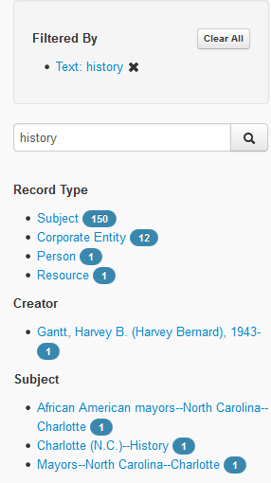

- Sort the list of retrieved records: Click on the desired sort order in the Sort by dropdown menu in the top right corner of the records list display. Agent records may be sorted by Relevance, Title, Date Created, Date Modified, and Record Type.

Browse for an Agent Record

The Browse search on the main toolbar performs a search by record type and displays the results in the order selected in the Sort by box in the top right corner of the result display.
On the main toolbar, click Browse and select Agents. A list of all the agent records in the repository will display.

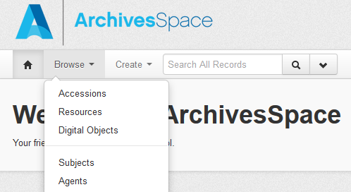

- You can perform the following operations to find a particular agent record:

  - Narrow the list of retrieved records: Click on the available filters on the left side of the records list. Examples: Record Type, Source, Rules.

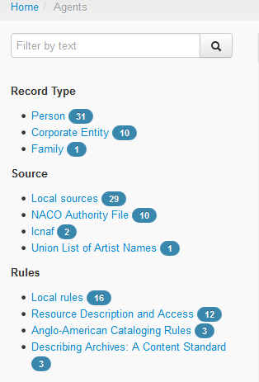
- Sort the list of retrieved records: Choose the desired sort order with the two Sort by dropdown menus box in the top right corner of the records list display. Agent records may be sorted by Terms Ascending, Terms Descending, Created Ascending, Created Descending, Modified Ascending, and Modified Descending.

View an Agent Record

Use Search or Browse to find the agent record you want to view. Click the View button on the right to see the record.

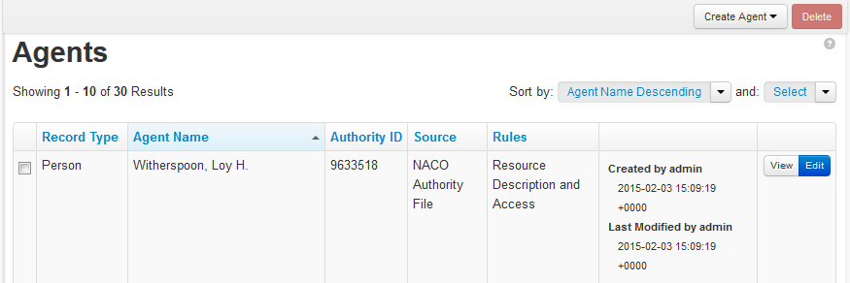

View an Agent Record in a New Window from inside an Accession, Resource, or Digital Object Record
This function enables an agent record to be opened in a new window from within an accession, resource, or digital object record and edited simultaneously.

- Navigate to the Agent Links sub-record of an accession, resource, or digital object record. Place your cursor over the agent highlighted in blue and click on it. A small View button will appear.

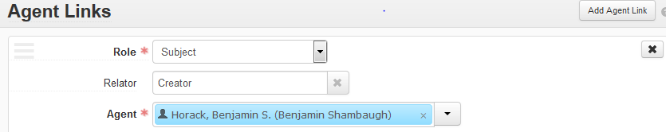
- Click on the View button. The subject record will open in a new window.

Edit an Agent Record

- On the main toolbar, click Browse and select Agent. Search and filter to find and select the agent you wish to edit.

- Click the Edit button, make the changes you wish, and then Save the record. The green bar on the screen will indicate that the record has been saved.

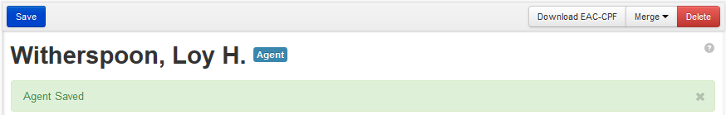
If the subject is missing any required fields, you will be prompted to complete them before saving the record.
Agent Record Toolbar Functions
An agent record has a unique toolbar with several features that will display depending on your login permissions and installation setup. The features you may see include: Save, Download EAC-CPF, Merge, and Delete.

Save: The Save button at the left of the bar is one of three ways to save a record. The others are the Save Person/CorporateEntity/Family/Software button in the navigation bar on the left and the Save Person/CorporateEntity/Family/Software button at the very bottom of the agent record.

Download EAC-CPF: This feature enables the downloading of an EAC-CPF (Encoded Archival Context for Corporate Bodies, Persons, and Families) record that has been automatically generated from the data entered in the agent record. Clicking the Download EAC-CPF button will cause a dialog box to appear that can be used to open the file with an XML editor or save it to your local machine.

Example:
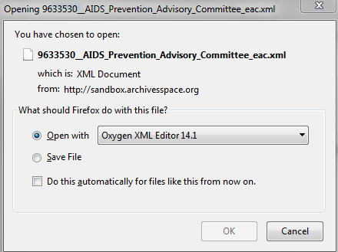

Merge: The Merge feature consolidates two or more separate agent records into one. See the Merge Agent Records section for more information on this feature.

Delete: The Delete button deletes the entire agent record from the database.

Save an Agent Record
There are three ways to save a save an agent record when you are in the edit view.
- The Save button located at the top of the subject record under the main tool bar.

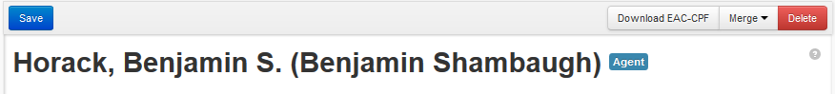

- The Save Person (or Corporate Entity, Family, or Software) button located at the bottom of the left navigation window.

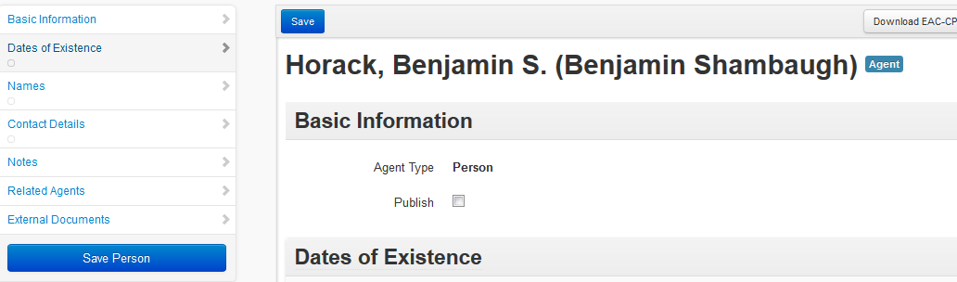

- The Save Person (or Corporate Entity, Family, or Software) button located at the bottom of the subject record.

Merge Agent Records

Merging agent records may be appropriate when a repository has been using two different records for the same agent and wishes to simplify usage by consolidating the terms into a single preferred term. The Merge function is also useful for cleaning up imported subject records and for performing subject record maintenance occasioned by updates to subject terms by the Library of Congress and other sources of controlled vocabularies.

Note that merging agents involves the permanent deletion of the agent record that is merged into another record. Any records that had been linked to the deleted agent record will now be linked to the merged agent record. This action cannot be reversed.

- Browse or Search for the record for the agent with which you would like to merge other agents. Click Edit or View at the far right of the agent record in the results list.

Caution: The record you are searching for in this step is the record you would like to preserve in the database. The records you would like to merge with this record and then delete are searched for in step 2, below.

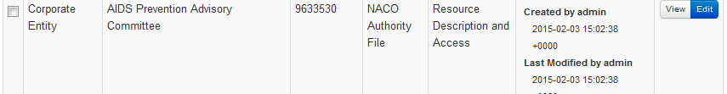

- Click the Merge dropdown menu at the upper right-hand corner of the agent record and type the first few letters of the agent you would like to merge with the agent represented by the current record. Matches will appear in pale blue. Click the term you wish to merge and then click Merge.

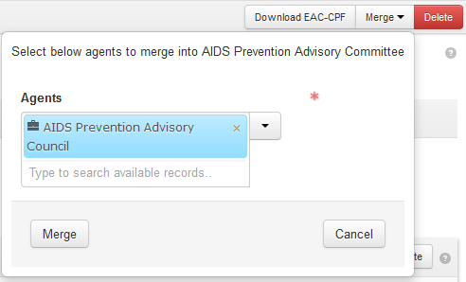

- A pop-up box will appear asking you to confirm your choice to merge the two records. Click Merge, or Cancel to abort the merge.

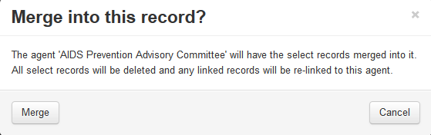

An alternative method involves browsing for the agent record to be merged.

- Click the dropdown menu arrow next to the Agents field and then click Browse.

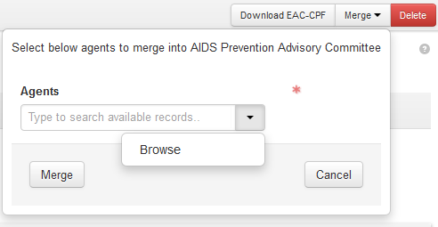

- In the pop-up box that will appear, browse for the subject that you wish to merge with the subject represented by the current record. Check the radio button to the left of the record in the results list and then Link to Agents. Clicking Link to Agents will insert the name of the agent in the agents field in the pop-up Merge box on the record with which it will be merged.

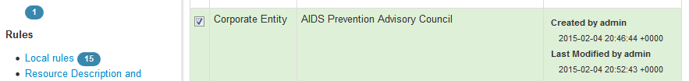

- When the correct agent record has been selected, click Merge.

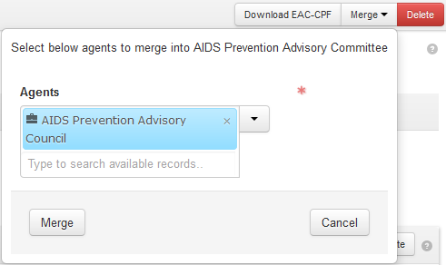

- A pop-up box will ask you to confirm whether you wish to merge the records. Click Merge, or click Cancel if you wish to abort the merge.

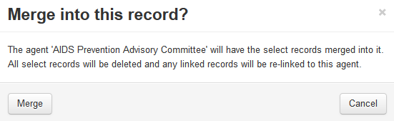

Delete Part of an Agent Record

- Use Search or Browse to find the agent record you want to edit.

- Click the Edit button at the right side of the appropriate record in the results list.

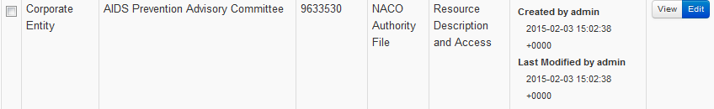

- When the record opens, click the sub-record section of the record you wish to delete on the left navigation bar. Then click the X in the upper right corner of the sub-record form.

Example:
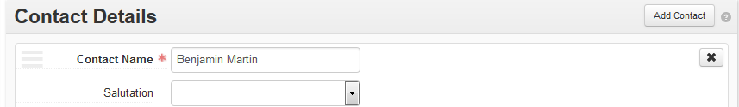

- Finally, click the blue Confirm Removal button that will appear in the upper right corner of the sub-record to delete it, or Cancel to retain it.

Example:
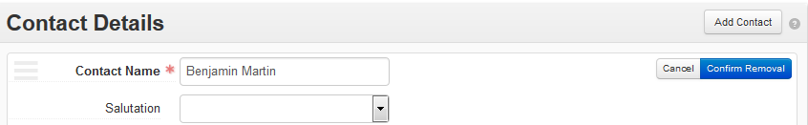

Delete an Entire Agent Record

Use Search or Browse to find the agent record you want to delete. If you use a browse search, you have two options for deleting an agent. If you use a keyword search (i.e., the search box), you will only be able to use option 2 (below) to delete an agent record.

- On the browse results screen, click the checkbox at the left of the record you wish to delete. Then click the red Delete button in the upper right corner.

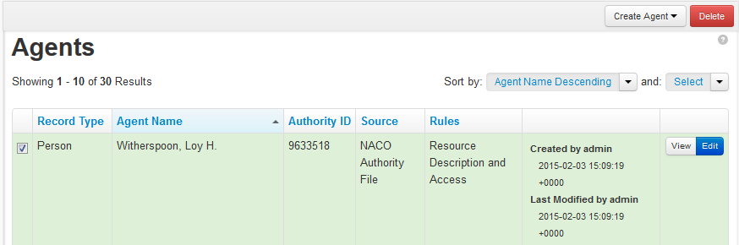

- On the results screen, click the Edit button to open the agent record in edit mode. Then click the red Delete button in the upper right-hand corner of the record.

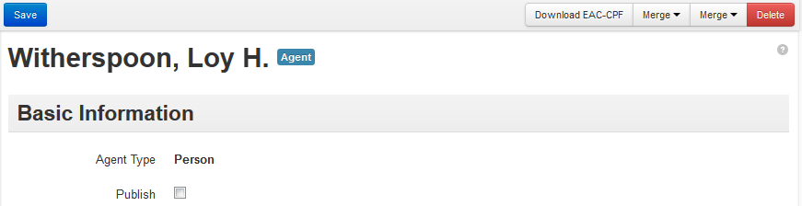

- In each case, the system will warn you that you are permanently deleting the record. Click Delete again to continue, or click Cancel or X to exit the screen without deleting the record.

Link an Accession, Resource, or Digital Object Record to an Agent

Required fields: Role, Agent

- On the navigation bar to the left of the Accession, Resource, or Digital Object record, click Agent Links. Then click Add Agent Link on the right side of the Agent Links sub-record. This command will open the Agent Links sub-record.

- In the Role dropdown menu, select a value that defines the relationship of the agent to the resource described in the record. Agents may be linked to records as creators, sources, or subjects.

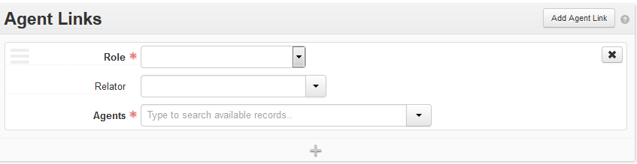

- You may give the agents who are creators a title in Title if you wish (an optional open text field that will appear when Creator is selected from the Role dropdown list). Title is a descriptive term for the relationship between the record and the agent, not a formal name element from an authority file or controlled vocabulary. Supplying a title for an agent is not an option if the agent is being linked as a source or subject.

- An optional relator term may be chosen using the dropdown menu to the right of Relator. Relator terms specify at a more granular level the agent’s relationship to the accession, resource, or digital object record (e.g., animator, author, dedicatee, donor, owner, etc.).

- In the agent field, type the first few letters of the agent you are seeking and click on the appropriate agent in the pale blue dropdown list that will appear. Remove unwanted terms by clicking on the small X at the bottom right-hand corner of the blue box containing the term. Multiple agents can be selected at this step if they all have the same role (e.g., they are all creators).

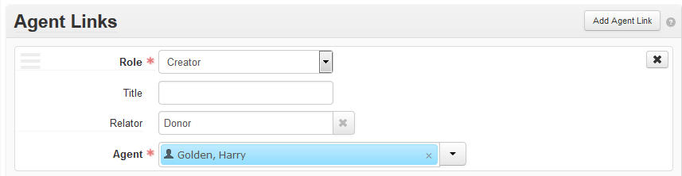

When you have selected the desired agent, Save the record.

Alternative methods of linking to agent records involve browsing the database for records or creating a new agent record if the desired record does not yet exist in the database.

- Click on the dropdown menu arrow beside the Agents field and choose Browse or Create.

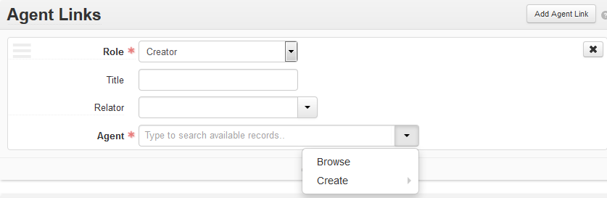

- The Browse command will cause a pop-up box to appear with a list of all available agent records. The default order is alphabetical by title, but the Sort By and Select dropdown menus at the top right-hand corner of the box enable agents to be sorted using two criteria simultaneously—ascending or descending title, ascending or descending creation date, ascending or descending modified date.

- To link the agent record, click on the radio button to the left of the agent term name. You can select more than one agent. Then click Link to Agents at the bottom of the Browse Agents pop-up box.

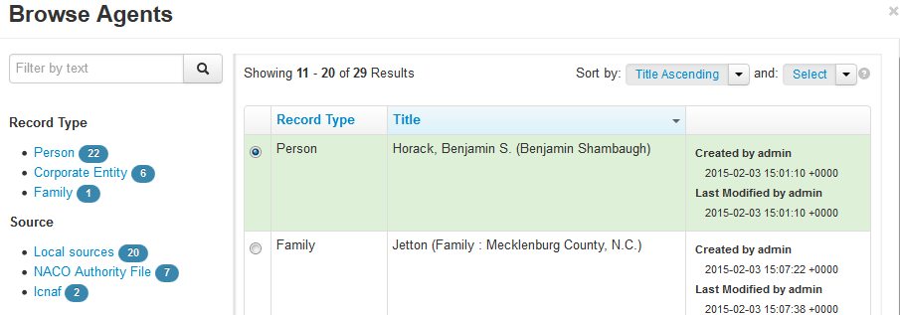

- Choose Create from the dropdown menu if no agent record is available for the agent you wish to link. Follow the instructions in Create a New Agent Record.

Remove an Agent Link from an Accession, Resource, or Digital Object Record

- Use Search or Browse to find the accession, resource, or digital object that contains the agent link you wish to delete.

- Click the Edit button at the right-hand side of the desired record in the results list.

- When the record opens, click Agent Links on the navigation bar to the left of the accession, resource, or digital object record to navigate to the Agent Links sub-records.

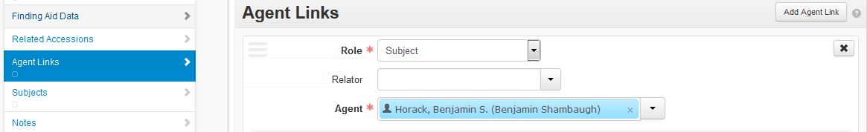

- Click on the X in the right corner of the agent link you wish to delete.

- Click the Confirm Removal button that will appear in the upper right corner of the section to delete the link, or Cancel to retain it.

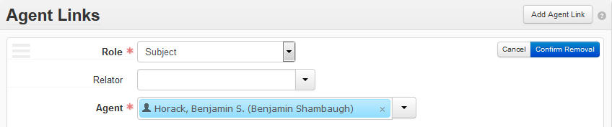

Import Agent Records in a MARCXML File

Agent records from an external source (e.g., the OCLC Connexion authorities file) may be imported into ArchivesSpace in a MARCXML file.

- Save the MARCXML file you have created from an external source to your desktop.

- On the Repository dropdown menu at the right of the ArchivesSpace homepage, select Import Jobs

- Click the Create Import Job at the top right of the Import Jobs page.

- Click the arrow at the right of the Import Type dropdown list and choose MARCXML (Subjects and Agents Only). Then click Add File.

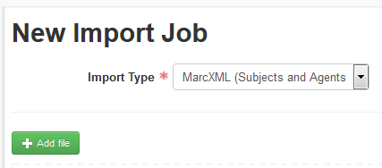

- Open the MARCXML file to be imported on your desktop. The name of the file will appear beneath the green Add File button in ArchivesSpace. Then click the blue Queue Import Job button beneath the name of the file.

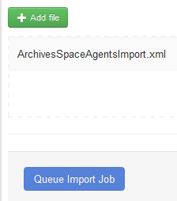

- ArchivesSpace will import the file, creating a log of import actions. When the file has been imported, a message in green indicating that the import job has completed will appear at the left of the screen.

- MARCXML records imported from other sources are often minimal, meaning that they include only the required fields. Such records can be enhanced with additional information after import if desired.

MARCXML agent records may require some cleaning up after import. Imported records may include improper punctuation (e.g. parentheses) in fields like Fuller Form, for instance, and Source information will be listed as “Unspecified ingested source.”

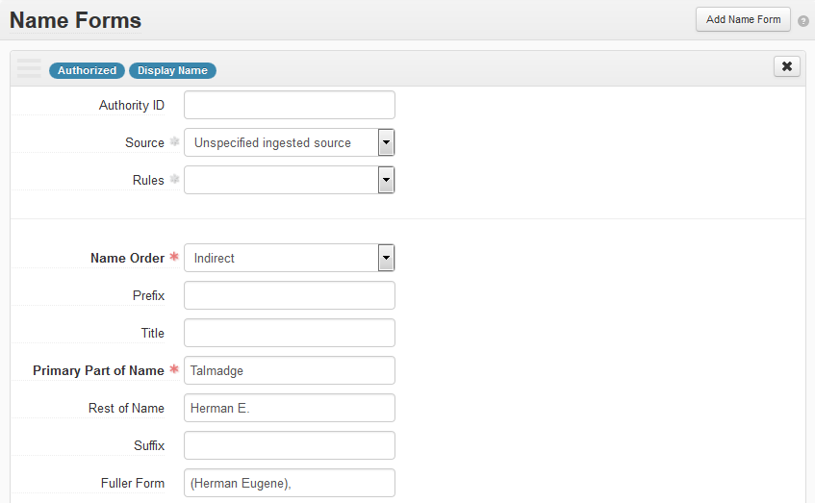

Import Agent Records with LCNAF Import Plug-in

Agent records may be imported from the Library of Congress Name Authority File with the LCNAF Import Plug-In. Currently the plug-in imports only records for persons.

- On the ArchivesSpace homepage, click the Repository menu and move your cursor to the Plug-Ins option. Click on the LCNAF Import button that will appear.

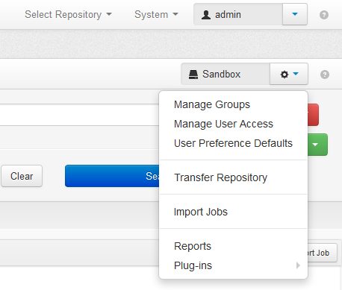

- On the NAF import page, enter the surname in the Primary Name field. Enter the forename in the Rest of Name field. Then click Search.

- Click the Select button to the left of the matching record in the search results list.

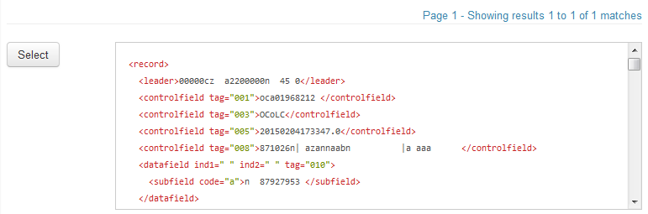

- Click the blue Import button at the right of the screen.

- ArchivesSpace will import the file, creating a log of import actions. When the file has been imported, a message in green indicating that the import job has completed will appear at the left of the screen.

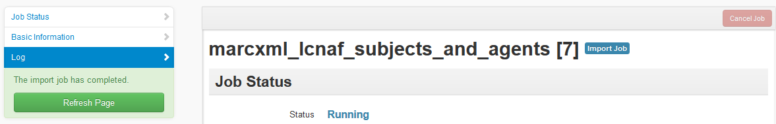

- Records from the LCNAF may require some cleanup after import. Imported records may include punctuation not used in ArchivesSpace in fields like Rest of Name, for instance.

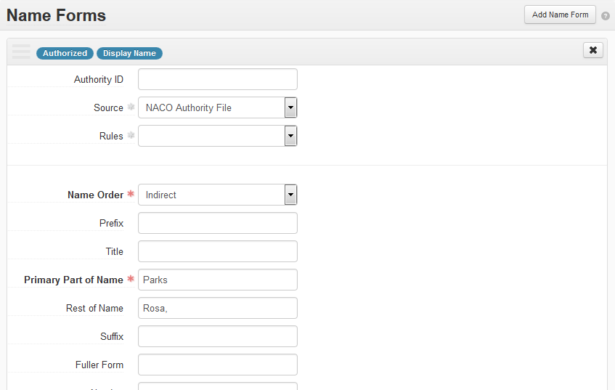
Comma after “Rosa” should be removed

Create a New Agent Record

Agent records may be created from within an accession, resource record, digital object record, or from the ArchivesSpace home page.

If you are already working in an accession, resource record, or digital object record:

- On the left navigation bar, click Agent Links. The record to the right will scroll down to the Agent Links sub-record. Click Add Agent Link on the right-hand side of the agent links sub-record. Then click the dropdown list button for Agents and select Create.

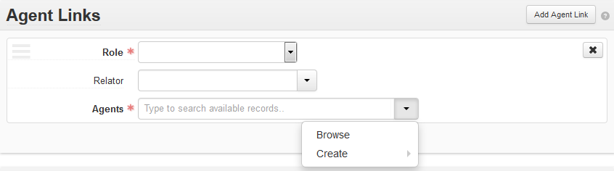

If you are starting from ArchivesSpace home:

- On the main toolbar, click Create and select Agent from the dropdown menu. From the sidebar dropdown menu to the right, select the type of agent record you wish to create: Person, Family, Corporate Body, or Software.

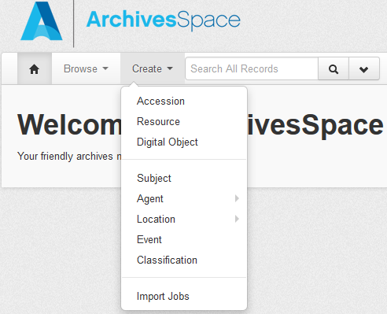

Agent Record Fields

Each record for a person, family, corporate body, or piece of software is made up of several sub-records, some of which contain fields that must be supplied in order to submit the new record to the database, others of which are optional. When a template for a new agent record is first opened, those sub-records that contain required fields will be open with all their fields exposed, while optional sub-records will be closed. The optional sub-records may be opened and completed by clicking on the “Add…” button (e.g., Add Contact, Add Note, Add Related Agent, etc.) to the right of the sub-record title.

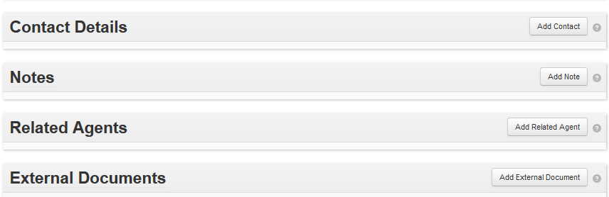

A minimal agent record may be created by filling in only the required fields. The minimal record can be enhanced later with additional fields.

Required Fields

Each agent type has several required fields associated with it. You must complete these in order to submit a new agent record to the database.

Person:

Primary Part of Name

Source or Rules

- Sort Name (automated if selected)

- Name Order (default value of “indirect” provided; you may change to “direct”)

Family:

- Family Name

- Source or Rules

- Sort Name (automated if selected)

Corporate Entity:

- Primary Part of Name

- Source or Rules

- Sort Name (automated if selected)

Software:

- Software Name

- Source or Rules

- Sort Name (automated if selected)

Basic Information Sub-Record

The Basic Information sub-record determines whether the agent information will be published to the public interface.

Fields:

- Publish (check box): When the box is selected, the information in the agent record will be published to the public interface. Leave the box unchecked if you don’t want the name to display publicly or be able to be searched in the public interface.

Dates of Existence Sub-Record

The Dates of Existence sub-record contains information about the dates in which the agent existed.

Required Fields if Dates of Existence Sub-Record is Created: Label and Type

Fields:

- Label (dropdown list): Existence is the only value available.

- Expression (open text field): A natural language expression specifying the date or date range associated with the existence of the person. Examples: 1968-, 1906 March 1-, 1833-1904.

- Type (dropdown list): Select Range for a date range, and Single for a single date (e.g., a birth date or a death date). Selecting Single will cause a new field, Begin, to appear below Type. Selecting Range will trigger the creation of two new fields, Begin and End.

- Begin (open text field; the calendar icon to the right of the field may be used to select a date automatically): A normalized date (in the form YYYY, YYYY-MM, or YYYY-MM-DD) representing a single date (e.g., a birth date) or the first date in a date range.

Note: A.D. years are expressed with four digits, while B.C. years are expressed
as a negative number (e.g., -214 for 214 B.C.).

- End (open text field; the calendar icon to the right of the field may be used to select a date automatically): A normalized date (in the form YYYY, YYYY-MM, or YYYY-MM-DD) representing a single date (e.g., a date of death) or the last date in a date range.

- Certainty (dropdown list): Indicates the level of confidence for the information given in a date statement. Use this optional field only when qualifying date information that is deemed to be uncertain based on the description or the cataloging rules in use.

- Era (dropdown list): Indicates the period during which years are numbered and dates reckoned, such as B.C. or C.E. The value “ce” is the default.

- Calendar (dropdown list): System of reckoning time, such as the Gregorian calendar or the Julian calendar. The value “Gregorian” is the default.

Example: Dates of existence sub-record for Person with date of birth 1902 and date of death 1981.

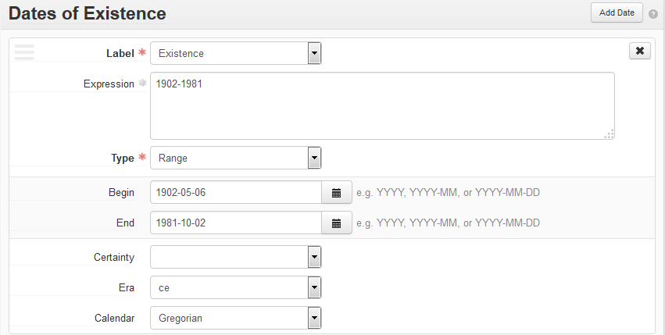

Name Forms Sub-Record

The Name Forms sub-record contains information about different forms of an agent’s name.

Fields:

- Authority ID (open text field): The unique identifier for the name form for an agent within the source from which it was acquired (e.g., a MADS record identifier or EAC record identifier). The identifier may be represented as a URI.

- Source (dropdown list): The authoritative source from which the name was taken. Four default values are available:

Local sources: Designates an authority file created and maintained at your repository.

NACO Authority File

NAD / ARK II Name Authority Database: Designates the National Archives Database of Sweden

Union List of Artist Names

The Source values in this dropdown list can be customized to include values from other controlled vocabularies or sources with the Manage Controlled Value Lists function.
- Rules (dropdown list): Indicates the data content standard used to formulate the name entry. Use Rules only when a name has not been found in an existing authority file and must be formulated locally. Four default values are available in the dropdown list:

Anglo-American Cataloging Rules

Describing Archives (DACS): a Content Standard

Local rules: Designates a data content standard created and maintained locally by your repository

Resource Description and Access

The Rules values in this dropdown list can be customized to include values from other controlled vocabularies or sources with the Manage Controlled Value Lists function.

- Software Name (open text field; not used on Person, Corporate Entity, or Family records): Indicates the name of a software package. Example:

  - ORB (Computer file) (for ORB (Computer file)[software])

- Name Order (dropdown list): Indicates whether the name should be displayed in inverted (last name, first name) order or in direct order (first name last name).

- Prefix (open text field): Enter any term associated with a name that in normative use would precede the entire name (e.g., Mrs., Mr., Dr.).

- Title (open text field): Enter a title that is part of the name. Examples:

  - Sir (for Churchill, Winston, Sir, 1874-1965 [person])
  - Chief (for Black Foot, Chief, d. 1877 [person])
  - Emperor of the East (for John II Comnenus. Emperor of the East [person])

- Primary Part of Name (open text field; called Family Name on Family records; not used on Software records): The primary part of a name form (e.g. a last name or surname of a person). Separates the principal sorting element of the name from the remainder of the name, which is generally input in the Rest of Name field. Examples:

  - Churchill (for Churchill, Winston, Sir, 1874-1965 [person])
  - Black Foot (for Black Foot, Chief, d. 1877 [person])
  - Sackville-West (for Sackville-West, V. (Victoria), 1892-1962 [person])
  - Agrant (for Agrant (Family : 1894-1976 : S.D.) [family])
  - International Business Machines (for International Business Machines. Microelectronics Division [corporate entity])

- Rest of Name (open text field): The first name additional names (e.g., middle names) for the person named in the record.

  - Winston (for Churchill, Winston, Sir, 1874-1965 [person])
  - Humphrey (for Ward, Humphrey, Mrs., 1851-1920 [person])
  - V. (for Sackville-West, V. (Victoria), 1892-1962 [person])

- Suffix (open text field): A term following a name that qualifies the name but is not a title. Example:

  - père (for Dumas, Alexandre, père [person])

- Fuller Form (open text field): The fuller form of first and middle names, when abbreviated. Example:

  - Hilda Doolittle (for H.D. (Hilda Doolittle), 1886-1961 [person])
  - Victoria (for Sackville-West, V. (Victoria), 1892-1962 [person])

- Number (open text field): A number, sometimes with a term, that qualifies the name.

  - III (for Beck, William Henry, III, 1925- [person])

- Subordinate Name 1 (open text field; not used on records for Persons, Families, or Software): If needed, add the subordinate element that immediately follows the primary part of the name of a corporate entity. Example:

  - Microelectronics Division (for International Business Machines. Microelectronics Division [corporate entity])

- Subordinate Name 2 (open text field; not used on records for Persons, Families, or Software): If needed, add the subordinate element that immediately follows the primary part of the name of a corporate entity. Example:

  - Battalion, Royal Highlanders of Canada, 13th (for Canada. Canadian Army. Battalion, Royal Highlanders of Canada, 13th [corporate entity])

- Manufacturer (open text field; found on Software records only): The manufacturer, creator, or other responsible party for a software package’s distribution, development, or maintenance. Example:

  - American Institute of Aeronautics and Astronautics (for ORB (Computer file)[software])

- Qualifier (open text field): A term or phrase for distinguishing two name forms identical in all other respects but identifying two different entities. The term may be a date, a place, or any other suitable descriptor. Examples:

  - Musician (for Balogh, István (Musician)[person])
  - Florists (for Smith family (Florists) [corporate entity])
  - Bronx, New York, N.Y. (for St. James Church (Bronx, New York, N.Y.)[corporate entity])

- Version (open text field; found on Software records only): Indicates the version number or other indicator for a specific version of a software package. Example:

  - 3.0 (for OCLC CJK [software])

- Sort Name (automatically generated): After you save the agent record, the system generates the contents of this field. This version of the name is a concatenation of all the parts of the name provided in the given agent record. Used for display purposes in the application and for some exports. The sort name may be edited by clearing the "Automatically generate" check box and then entering the form of the sort name desired.

Date(s) of Name Use Sub-Sub Record

A part of the Name Forms sub-record, the Date(s) of Name Use records information about the dates during which the name of a particular agent was in use. This record might be used, for example, to record the dates during which a corporate entity that has changed its name used a preceding name.

Fields:

- Label (dropdown list): The only available value is Usage.

- Expression (open text field): A natural language expression specifying the date or date range when the name for the agent was used. Examples: 1968-, 1953 March 1-, 1925-1964.

- Type (dropdown list): Select Range for a date range, and Single for a single date (e.g., a birth date or a death date). Selecting Single will cause a new field, Begin, to appear below Type. Selecting Range will trigger the creation of two new fields, Begin and End.

- Begin (open text field; or the calendar icon to the right of the field may be used to select a date automatically): A normalized date (in the form YYYY, YYYY-MM, or YYYY-MM-DD) representing a single date (e.g., a birth date) or the first date in a date range.

- End (open text field; or the calendar icon to the right of the field may be used to select a date automatically): A normalized date (in the form YYYY, YYYY-MM, or YYYY-MM-DD) representing a single date (e.g., a date of death) or the last date in a date range.

- Certainty (dropdown list): Indicates the level of confidence for the information given in a date statement. Use this optional field only when qualifying date information that is deemed to be uncertain based on the description or the cataloging rules in use.

- Era (dropdown list): Indicates the period during which years are numbered and dates reckoned, such as B.C. or C.E. The value “ce” is the default.

- Calendar (dropdown list): System of reckoning time, such as the Gregorian calendar or the Julian calendar. The value “Gregorian” is the default.

Example 1:
Name Forms sub-record for Personal Name: Compton-Burnett, I. (Ivy), 1884-1969.

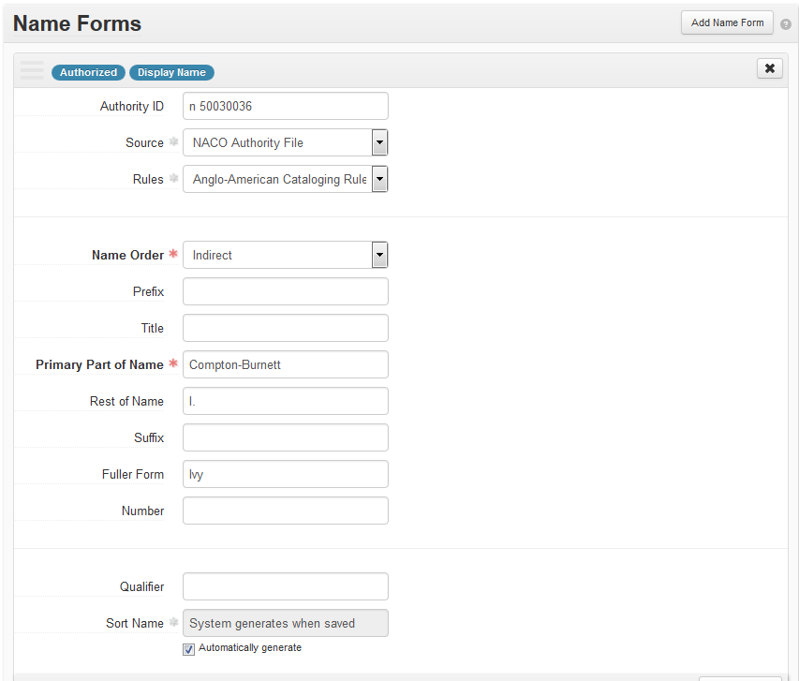

Example 2:
Name Forms sub-record for Family: Jetton (Family : Mecklenburg County, N.C.).

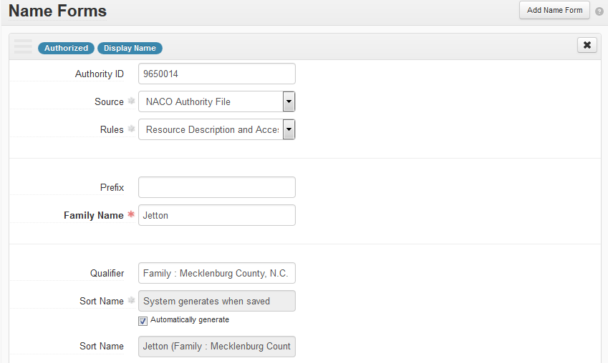

Example 3:
Name Forms sub-record for Corporate Entity: Canada. Canadian Army. Battalion,
Royal Highlanders of Canada, 13^{th.}
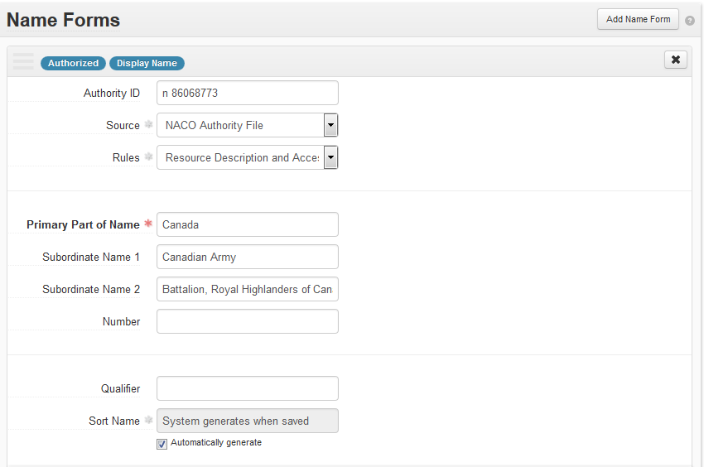

Example 4:
Name Forms sub-record for Software: ORB (Computer file).

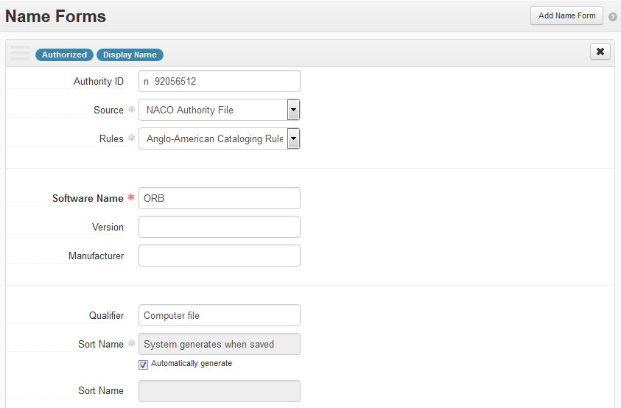

Contact Details Sub-Record

The Contact Details sub-record contains contact information for the entity recorded in the main record.

Required Fields: Contact Name

Fields:

- Contact Name (open text field): Name of the person serving as contact for the entity in the main record.

- Salutation (dropdown list): Salutation for the contact person (e.g., Dr., Mrs., Mr.).

- Address (open text field): Address for the contact person.

- City (open text field): City in which the contact person is located.

- State/Region (open text field): State or Region in which the contact person is located.

- Country (open text field): Country in which the contact person is located.

- Post Code (open text field): Mail or zip code for the contact person’s address.

- Telephone (open text field): Telephone number for the contact person.

- Telephone Extension (open text field): Telephone number extension for the contact person.

- Fax (open text field): Fax number for the contact person.

- E-mail (open text field): Email address for the contact person.

- Contact notes (open text field): Additional notes or information about the contact person.

Notes Sub-Record

The Notes sub-record contains additional descriptive information about an agent, such as a biographical note or an administrative history.

Required fields: Note Type, Content

Fields:

- Note Type (dropdown list): Note types are used to guide the export of note contents to certain elements in specific data formats. The only available value is Biographical / Historical for all agent types.

- Persistent ID (automatically generated): This value is automatically generated by the system when an agent record is created.

- Label (open text field): A label or heading for the specific note. If a label is not used, the value chosen from the dropdown menu in Note Type will be used as the label wherever required.

- Publish (check box): When the box is selected, the information in the Notes sub-record will be published to the public interface. Leave it unchecked if you don’t want the note to display.

- Content (open text): Located in Text section of the Notes sub-record, this field contains the content of the note. The Content note allows for mixed content, which includes both text and XML markup. Typing “<” will trigger the appearance of a dropdown list of EAD elements (e.g., language, blockquote, date, function, occupation, persname, etc.) that can be used to wrap elements of the Content text. Highlighting text in Content will cause the same dropdown list of EAD elements to appear.

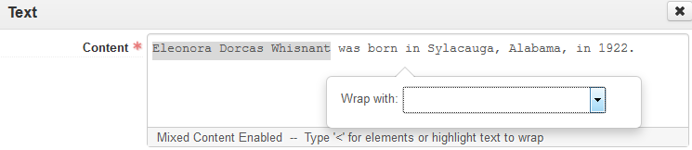

Related Agents Sub-Record

The Related Agents sub-record contains information about other agents with which the agent described by the record may be associated (e.g., former and later name relationships, parent/child relationships, other associative relationships). The option to add related agents for software is not available.

Required fields: Relationship Type, Related Agent

Fields:

- Relationship Type (dropdown list): Specifies the type of relationship recorded. Choosing a value from this dropdown list will trigger the appearance of a second Relationship Type field with a dropdown list where the more general relationship type described here can be further specified. Values in both lists are as follows:

1st Relationship Type Field | 2nd Relationship Type Field
Associative Relationship | Associative with Related
Earlier/Later Relationship | Earlier Form of Related  Later Form of Related
Parent/Child Relationship | Child of Related  Parent of Related

- Related Agent (dropdown list): Links the Agent represented by the current record with other related Agent records.

You can create an agent link by typing the first few letters of the agent’s name in the Related Agents field and clicking on it. The selected agent will appear in the field, highlighted in blue. To remove it, click on the small “x” at the lower right-hand corner of the field.

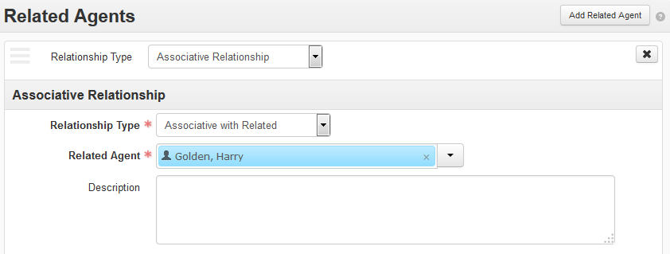

Alternative methods of creating a related agent link involve using Browse to locate an agent record or Create to create a new agent record if the desired record does not yet exist in the database.

- Click on the dropdown arrow to the right of the field and choose Browse or Create.

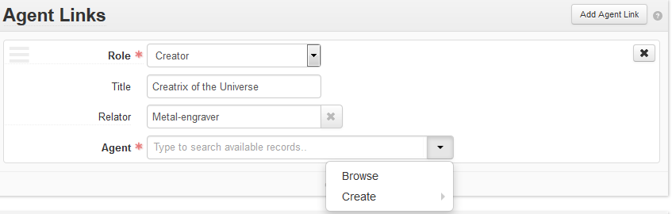

- Selecting Browse will cause a pop-up box to appear with a list of all the agent records available in your ArchivesSpace instance.

- To link the agent record to a related agent, click the radio button to the left of the appropriate agent name. Then click Link to Agents at the bottom of the pop-up box.

- Choose Create from the dropdown menu if no agent record is available for the agent you wish to link. Follow the instructions in Create a New Agent.

- Description (open text field): A description of the relationship, if warranted.

Dates Sub-Record

The Dates sub-record of the Related Agents Sub-Record records information about dates associated with a related agent (e.g., the dates of existence of a related corporate body, the birth date and death dates of a related person, etc.).

Required fields: Label, Type

Fields

- Label (dropdown menu): A term describing the type of date recorded in the Dates sub-record (e.g., agent relation, existence, other).

- Expression (open text field): A natural language expression specifying the date or date range associated with the relationship with the related agent.

- Type (dropdown menu): Select Range for a date range, and Single for a single date (e.g., a birth date or a death date). Selecting Single will cause a new field, Begin, to appear below Type. Selecting Range will trigger the creation of two new fields, Begin and End.

- Begin (open text field; the calendar icon to the right of the field may be used to select a date automatically): A normalized date (in the form YYYY, YYYY-MM, or YYYY-MM-DD) representing a single date (e.g., a birth date) or the first date in a date range.

Note: A.D. years are expressed with four digits, while B.C. years are expressed
as a negative number (e.g., -214 for 214 B.C.).

- End (open text field; the calendar icon to the right of the field may be used to select a date automatically): A normalized date (in the form YYYY, YYYY-MM, or YYYY-MM-DD) representing a single date (e.g., a date of death) or the last date in a date range.

- Certainty (dropdown list): Indicates the level of confidence for the information given in a date statement. Use this optional field only when qualifying date information that is deemed to be uncertain based on the description or the cataloging rules in use.

- Era (dropdown list): Indicates the period during which years are numbered and dates reckoned, such as B.C. or C.E. The value “ce” is the default.

- Calendar (dropdown list): System of reckoning time, such as the Gregorian calendar or the Julian calendar. The value “Gregorian” is the default.

External Documents Sub-Record

The External Documents sub-record contains links to any external documentation about the agent (e.g., biographical files, reference works, etc.).

Fields:

- Title (open text field): The title of an external document referenced from the accession record. The document may be of any form or content (e.g., web accessible file, a network accessible file, a file on the same computer as the application, etc.).

- Location (open text field): The location of the file, ideally a resolvable URI. Examples: http://www.archivesspace.org/membershipfile:///c:/path/to/the%20file.txt.

- Publish (open text field): A selected check box indicates that this External Document should be published to the public interface.

