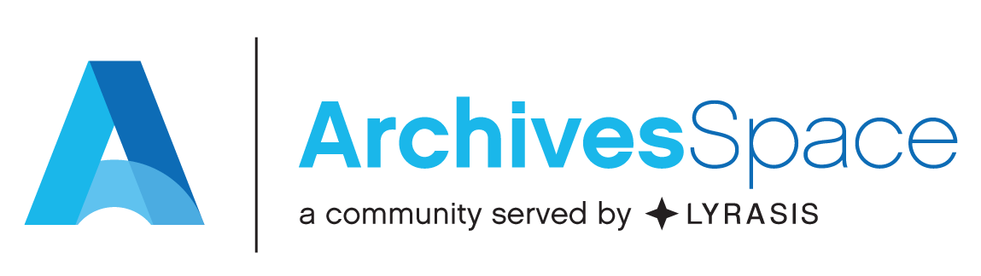
ArchivesSpace Basics Virtual Workshop
Temple University
Live Sessions: September 29, October 1, 6 and 8 from 1pm-3pm ET
Connection Information: [Zoom link]

Course materials: https://bit.ly/2Fdgvr0
Learning objectives:
Upon completing this workshop, you’ll have learned how to use ArchivesSpace to:
- Create Repository and User records
- Create Accession records
- Create Resource records
- Record and manage physical locations within a repository.
- Create and manage Agent and Subject records, and link them to Accession, Resource, and Digital
Object records.
- Produce description output files in standardized data structures such as EAD and MARCXML.
- Import legacy data.
- You will also become more familiar with:
  - Applying the DACS content standard where applicable, to determine the kind and form
of data recorded in an ArchivesSpace record.
  - Technical and administrative issues relevant to customizing and managing
ArchivesSpace at a repository.
What won’t be covered:
This workshop will not cover, or will only cursorily touch on, the following aspects of ArchivesSpace:

- Installing, upgrading and repairing the application.
- Working with the underlying database application.
- The following specific ArchivesSpace functional areas and processes:
  - Digital Object Records
  - Event records
  - Collection Management records
  - Rights records
  - Agent contact information / contact logs
  - Multi-part notes
  - Merge/Transfer functions for major record types
  - Assessment records
  - Mapping legacy data.
  - Customizing the ArchivesSpace public interface.
  - Producing administrative reports.
Participant Expectations:
  - Complete the pre-workshop survey at [link]
  - Confirm in advance of the first live session that Zoom connection information and all resource links work as expected on the computer or laptop you will be using for the workshop.
  - Register for an ArchivesSpace Help Center account. You will need this account to review recordings and supplemental documentation. If you do not already have a Help Center account, you can learn more about creating one at https://archivesspace.atlassian.net/wiki/spaces/ADC/pages/917045261/ArchivesSpace+Help+Center
  - Complete all “homework” in advance of each live session, including reviewing video recordings and completing exercises.
  - Actively participate in live sessions, including unmuting and asking questions or interacting via the Zoom chat feature.

Workshop Agendas and Assignments:

September 29, 2020
Pre-workshop assignments:
Please review the following recordings
Staff User Interface Functional Overview
https://archivesspace.atlassian.net/wiki/spaces/ArchivesSpaceUserManual/pages/915144850/Staff+User+Interface
Public User Interface Functional Overview
https://archivesspace.atlassian.net/wiki/spaces/ArchivesSpaceUserManual/pages/915472388/Public+User+Interface
Repository Management Functional Overview
https://archivesspace.atlassian.net/wiki/spaces/ArchivesSpaceUserManual/pages/915374186/Repository+Management
User Management Functional Overview
https://archivesspace.atlassian.net/wiki/spaces/ArchivesSpaceUserManual/pages/915406946/User+Permission+Management

Agenda (All Times in ET):
1:00 pm | Introductions – Learning objectives & what won’t be covered
1:10 pm | Application Overview and Homework Recap
1:30 pm | Accession records
2:15 pm | BREAK (5 minutes)
2:20 pm | Resources Records: Main/Single Level Records
3:00 pm | Wrap Up

October 1, 2020

Pre-workshop assignments:

Please complete the following exercises in the training workbook
Exercise 1 – Accession Records
Exercise 2 – Resource Records (single level)
Review supplemental recordings (Optional)
Accession Records module
https://archivesspace.atlassian.net/wiki/spaces/ArchivesSpaceUserManual/pages/915439673/Accession+Records+Module
Resource Records module
https://archivesspace.atlassian.net/wiki/spaces/ArchivesSpaceUserManual/pages/915144879/Resource+Records+Module

Agenda (All Times in ET):
1:00 pm | Welcome back and homework recap
1:20 pm | Resource Records: Multi Level records
1:45 pm | Managing Instances and Top Containers
2:15 pm | Break (5 minutes)
2:20 pm | Rapid Data Entry
2:40 pm | Loading via Spreadsheet
3:00 pm | Wrap up

October 6, 2020

Pre-workshop assignments:

Please complete the following exercises in the training workbook
Exercise 3 – Resource records (multi-level and rapid data entry)
Review supplemental recordings (Optional)
Resource Records module
https://archivesspace.atlassian.net/wiki/spaces/ArchivesSpaceUserManual/pages/915144879/Resource+Records+Module

Agenda (All Times in ET):
1:00 pm | Welcome back and homework recap
1:20 pm | Location Records
2:00 pm | Break
2:05 pm | Agent Records
2:35 pm | Subject Records
3:00 pm | Wrap up and determine small group breakout topics for the final day

October 8, 2020

Pre-workshop assignments:

Please complete the following exercises in the training workbook
Exercise 4 – Location Records
Exercise 7 – Agent Records
Exercise 8 – Subject Records
Review supplemental recordings and resources (Optional)

Location Records module
https://archivesspace.atlassian.net/wiki/spaces/ArchivesSpaceUserManual/pages/915275852/Location+Records+Module
Agent Records module
https://archivesspace.atlassian.net/wiki/spaces/ArchivesSpaceUserManual/pages/915341364/Agent+Records+Module
Subject Records module
https://archivesspace.atlassian.net/wiki/spaces/ArchivesSpaceUserManual/pages/915406879/Subject+Records+Module

Agenda (All Times in ET):
1:00 pm | Welcome back and homework recap
1:30 pm | Reports
1:45 pm | Imports and Exports
2:00 pm | Data Clean-up
2:15 pm | Break
2:20 pm | Small group breakout discussions
2:50 pm | Final wrap up

Post workshop resources:
- Workshop evaluation: [LINK]
- Link to the ArchivesSpace Help Center: https://archivesspace.atlassian.net/wiki/spaces/ArchivesSpaceUserManual/overview
The Help Center contains additional user tutorial videos and the ArchivesSpace User Manual.
- List of commonly used member resources: https://archivesspace.org/using-archivesspace/member-resources
- Upcoming ArchivesSpace webinars and previous webinar recordings: https://archivesspace.org/using-archivesspace/webinars
- Introduction to ArchivesSpace virtual training recorded April 2020: https://www.youtube.com/playlist?list=PL3cxupmXL7WiHyMc0uFmsCEIVOQmrI7FL
- Explanation of how to receive technical support: https://archivesspace.org/member-area/technical-support
- Migration Tools and Data Maps: https://archivesspace.org/using-archivesspace/migration-tools-and-data-mapping
- Recent webinar on understanding the ArchivesSpace config file presented by Atlas Systems: [TBA]

