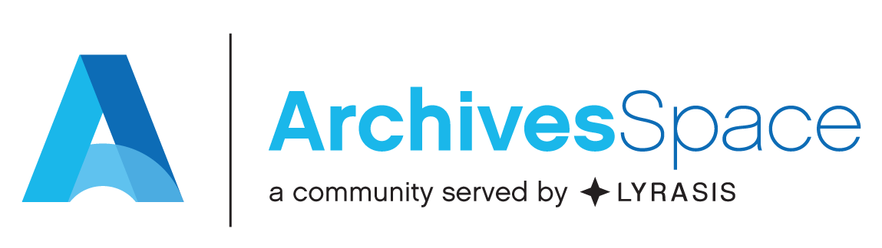
ArchivesSpace Basics Virtual Workshop
Live Sessions: May 11, 13, 18, 20, 2021 at 12:00pm-2:30pm ET
Connection Information: Sent directly via Zoom

Course materials:
Learning objectives:
Upon completing this workshop, you’ll have learned how to use ArchivesSpace to:
- Create Accession records
- Create Resource records
- Digital Object Records
- Record and manage physical locations within a repository.
- Create and manage Agent and Subject records, and link them to Accession, Resource, and Digital
Object records.
- Produce description output files in standardized data structures such as EAD and MARCXML.
- Import legacy data.
- Producing administrative reports.
- You will also become more familiar with:
  - Applying the DACS content standard where applicable, to determine the kind and form
of data recorded in an ArchivesSpace record.
  - Technical and administrative issues relevant to customizing and managing
ArchivesSpace at a repository.
What won’t be covered:
This workshop will not cover, or will only cursorily touch on, the following aspects of ArchivesSpace:

- Installing, upgrading and repairing the application.
- Working with the underlying database application.
- The following specific ArchivesSpace functional areas and processes:
  - Repository Management
  - User Management
  - Event records
  - Collection Management records
  - Rights records
  - Agent contact information / contact logs
  - Multi-part notes
  - Merge/Transfer functions for major record types
  - Container and space management
  - Assessment records
  - Mapping legacy data
  - Customizing the ArchivesSpace public interface
  - Troubleshooting attendees’ own instances of ArchivesSpace
Participant Expectations:
  - Complete the pre-workshop survey
  - Confirm in advance of the first live session that Zoom connection information and all resource links work as expected on the computer or laptop you will be using for the workshop. The use of tablets and cell phones during this workshop is discouraged. We cannot provide technical assistance to individuals using tablets or cell phones during this workshop.
  - Complete all “homework” in advance of each live session, including reviewing video recordings and completing exercises.
  - Actively participate in live sessions, including asking questions or interacting via the Zoom chat feature.
Workshop Agendas and Assignments (all times in ET):

Day 1

Agenda:
12:00 pm | Introductions – Learning objectives & what won’t be covered
12:15 pm | Application Overview
12:45pm | Accession records
1:30 pm | BREAK (15 minutes)
1:45 pm | Resources Records: Main/Single Level Records
2:15 pm | Questions and Wrap Up

Day 2

Pre-workshop assignments:

Please complete the following exercises in the training workbook
Exercise 1 – Accession Records (page 47)
Exercise 2 – Resource Records-single level (page 61)
In the interest of time and in order to answer as many questions as possible, please submit your homework related questions in advance of the day's workshop via the form provided. You may submit your question anonymously.

Agenda:
12:00 pm | Welcome back and homework recap
12:30 pm | Resource Records: Multi Level records
12:55 pm | Managing Instances and Top Containers
1:25 pm | Break (15 minutes)
1:40 pm | Rapid Data Entry
2:00 pm | Loading via Spreadsheet
2:15 pm | Questions and Wrap up

Day 3

Pre-workshop assignments:

Please complete the following exercises in the training workbook
Exercise 3 – Resource records-multi-level and rapid data entry (page 68)
In the interest of time and in order to answer as many questions as possible, please submit your homework related questions in advance of the day's workshop via the form provided. You may submit your question anonymously.

Agenda:
12:00 pm | Welcome back and homework recap
12:30 am | Digital Object Records
1:15 pm | Break (15 minutes)
1:30 pm | Agent Records
1:55 pm | Subject Records
2:15 pm | Questions and Wrap up

Day 4

Pre-workshop assignments:

Please complete the following exercises in the training workbook
Exercise 5 – Build a Simple Digital Object (page 91)
Exercise 6 (optional) – Build a Complex Digital Object (page 95)
Exercise 7 – Agent Records (page 106)
Exercise 8 – Subject Records (page 112)
In the interest of time and in order to answer as many questions as possible, please submit your homework related questions in advance of the day's workshop via the form provided. You may submit your question anonymously.

Agenda:
12:00 pm | Welcome back and homework recap
12:30 pm | Location Records
1:00 pm | Imports
1:15 pm | Break (15 minutes)
1:30 pm | Exports and Reports
1:50 pm | Data Cleanup and Customization
2:15 pm | Final Wrap Up

Post workshop resources:
- Workshop evaluation
- Link to the ArchivesSpace Help Center (ArchivesSpace members only): https://archivesspace.atlassian.net/wiki/spaces/ArchivesSpaceUserManual/overview
The Help Center contains additional user tutorial videos and the ArchivesSpace User Manual.
- ArchivesSpace Getting Started resources and videos: https://archivesspace.org/using-archivesspace/getting-started
- ArchivesSpace Virtual Community-wide training schedule: https://archivesspace.atlassian.net/wiki/spaces/ADC/pages/2331148319/ArchivesSpace+Community-Wide+Virtual+Training
- Upcoming ArchivesSpace webinars and previous webinar recordings: https://archivesspace.org/using-archivesspace/webinars
- List of commonly used member resources (ArchivesSpace members only): https://archivesspace.org/using-archivesspace/member-resources
- Explanation of how to receive technical support (ArchivesSpace members only): https://archivesspace.org/member-area/technical-support
- Migration Tools and Data Maps: https://archivesspace.org/using-archivesspace/migration-tools-and-data-mapping

