An accession record has a unique toolbar with several options: View Published, Add Event, Spawn, Transfer, More, Suppress, and Delete.

View Published accession record
If the accession has been published to the ArchivesSpace Public Interface, click the View Published button on the accession toolbar to open the public view of the selected record in a new browser window.

Add Event to an accession record
For detailed information on Event records see the Events chapter of this manual. To add an event record to an accession, click the Add Event button and choose one of the event types from the drop down menu.
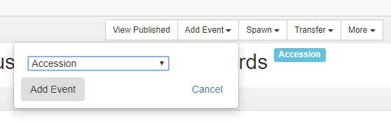
Then click Add Event - or Cancel if you change your mind.

The system will then open a New Event screen. Fill out the fields in this screen in accordance with the instructions in the Events chapter of this manual. After you save the event the system will automatically return you to the accession record you were working with.

To spawn a resource record or an accession record

About spawning
The information in an accession record can be transferred (a new record is the "spawn”) to a new accession or resource record. When spawning an accession record, the two records are not automatically linked and you will need to declare the relationship in the Linked Accessions section in each record. When spawning a resource record, ArchivesSpace does automatically link the two records, and transfers specific information from the accession record to the resource record. Edits to the spawned accession and record records do not affect the accession record from which they came.
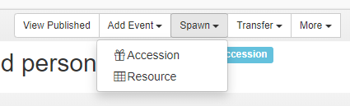

To spawn an accession record from an accession record
Find the accession record you want to turn (spawn) into a new accession record and then, click View or Edit.
Once you are in the accession record, click Spawn, and select Accession. The new editable accession record displays. The new record is a duplicate of the original accession record.
Before you can save the new record, you must enter a new and unique accession identifier. No other change is required by the system, though you will probably want to edit the record to distinguish the record from the original.
To designate the relationship between the new and the original accession records, see the Related Accessions section of this documentation.

To spawn a resource record from an accession record
Find the accession record you want to turn (spawn) into a core resource record (spawn), click View or Edit.
Once you are in the accession record, click Spawn, and select Resource. The new editable resource record displays.
The system will then open a new resource record containing information from the accession record. Note that the screen also has a Return to Accession button. This enables you to back out of creating the resource and is only available until you save the resource record. Add the additional required fields to the resource record (see the Resources section of this manual for details) and click Save Resource.
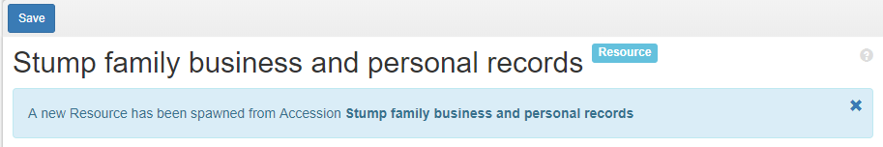

What information is transferred to a resource from a spawned accession record?
The following table lists all of the elements that are mapped from the accession record to a spawned resource record.

Note: When spawning a resource record from an accession record that is linked to another accession record, only the data from the primary accession record will be transferred to the new resource record.
Accession record  (field labels) | Resource record  (field labels)
Identifier | (linked under Related Accessions)
Title | Title
Resource type | Resource type
Publish | Publish
Content Description | Note Type=”Scope and content note”
Condition Description | Note Type=”Physical description note”
Linked sub-records:  • Dates  • Extents  • Rights | Linked sub-records:  • Dates  • Extents  • Rights
Linked records:  • Subjects  • Agents | Linked records:  • Subjects  • Agents

To transfer an accession record
The Transfer button allows a user to transfer an accession to another repository within an ArchivesSpace implementation. This functionality requires that there be two or more repositories defined in an ArchivesSpace implementation, and it is only initially available to System Administrators, though it can be assigned to other users according to the needs and polices of the repository. See the User section of this manual for more detail.
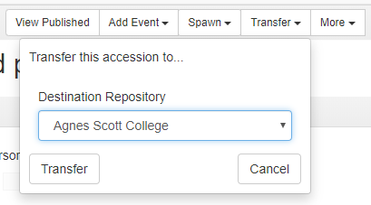
Choose the repository you wish to transfer the record to from the drop down menu, then click Transfer.

You may click Cancel from either screen to stop the transfer.

More functions: Calculate Extent and Create Assessment
You can select Calculate Extent and Create Assessment directly from the Accession Record Toolbar by clicking on the More button. See the Space Calculator and Managing Assessments sections of this manual for more information on these functions.
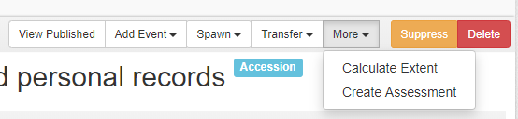

To suppress an accession record
A suppressed record will remain in the database, but it can be hidden to most staff users and unavailable to most functions, including searching, browsing, or reporting. The functionality can be useful to retain records for accessions that have been completely deaccessioned from the repository, or to restrict access to unfinished records or to records of confidential material. Once the record is suppressed, only authorized users will be able to find it in the system. If you suppress a published record, the suppression will take priority over the publish function All suppressed records can be unsuppressed.
To suppress a record, click the yellow Suppress button. You will see the following results:
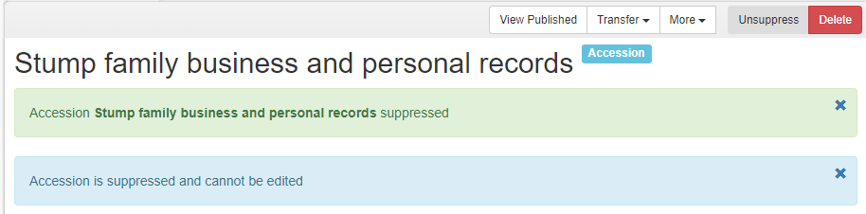
Click the Unsuppress button to return the record to an editable and viewable state for most users.

To delete an accession record
The Delete button allows you to remove an accession record, including any references it has to other records, from the database. Please be aware you cannot undo this action.

