Rights Statements Sub-Record (v2.1.0 and later)
The Rights Statement sub-record is for recording information about the rights status of the material being described. It can be used for aggregates of material or single items.
Rights statements can only be created within the context of a material description record, either accessions, resources, resource components, digital objects, or digital object components. The rights statements cannot be viewed or edited independently of their context, although reports based on them may be generated. To view the rights associated with an accession, collection, or object, you must navigate to that object and view the rights statement embedded within it.
Like other record types in ArchivesSpace, the Rights Statement sub-record also allows the option of linking to one or more external documents, such as deed of gift in which copyright is transferred, or an institutional policy.
The rights sub-record has few required fields. Each repository should develop its own policies and procedures for determining when and how these fields should be used and at what level of description.
You may add as many rights statements as necessary to account for the rights status of the materials being described. For instance, it is possible some materials may be subject to intellectual property laws, to licenses such as donor agreements, and to institutional policies. Each rights status may have explicit or implied permissions / restrictions associated with it that are not present with another rights status.
Finally, it is recommended that repositories supplement the rights sub-record with a corresponding notes of the type Conditions Governing Access or Conditions Governing Use.

To create a Rights Statement sub-record (v2.1.0 and later)
For version 2.1.0, the rights statements module was significantly enhanced. These enhancements enable:
- the expression of “atomic” rights statements
- greater interoperability between ArchivesSpace and preservation management and discovery systems
- making ArchivesSpace compliant with the PREMIS rights schema
To add a rights statement click on Rights Statement in the left navigation bar of a material description record and then click Add Rights Statement on the right side of the screen.
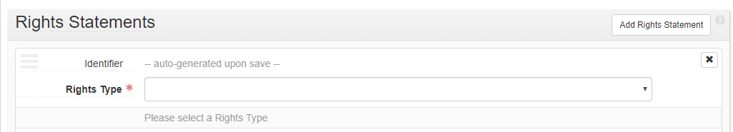

- Identifier: Uniquely identifies the rights statement within the repository domain. Rights Statement identifiers are usually auto-generated by the application.
- Rights Type: (Required) Select from drop-down list, which may not be configured.
Depending on the Rights Type you select, additional rights related fields will appear, some of which will be required for the type selected.
You may save the material description record you are in once you select the Rights Type and complete any fields that type may require. The system will supply an identifier which will appear as follows:
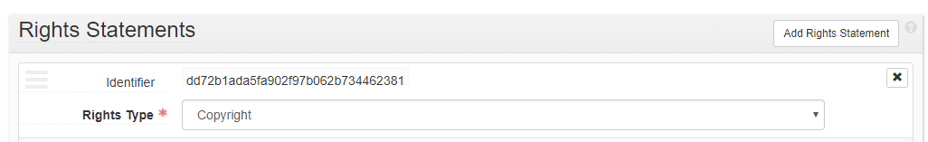

Copyright
When you select Rights Type "Copyright", you will see the following fields:
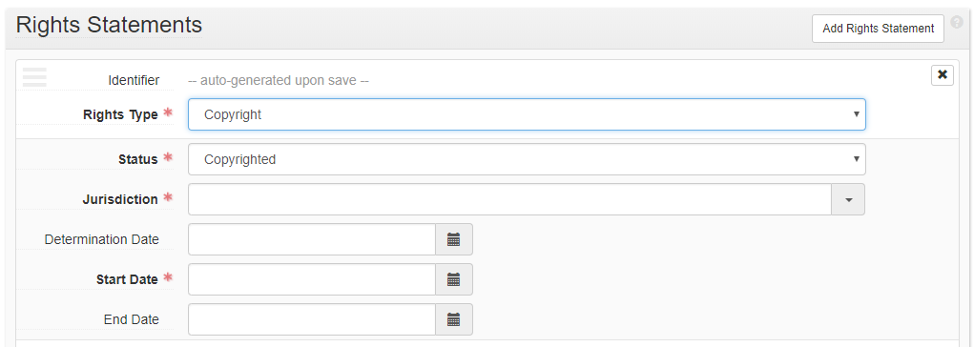
- Status (Required)- A coded designation for the copyright status of the object at the time the rights statement is recorded.
- Jurisdiction (Required) - The country whose copyright laws apply.
- Determination Date - The date the copyright status recorded in copyright status was determined.
- Start Date (Required) - The date the rights statement went into effect.
- End Date - The date the rights statement ends.

License
When you select Rights Type " License", you will see the following fields:
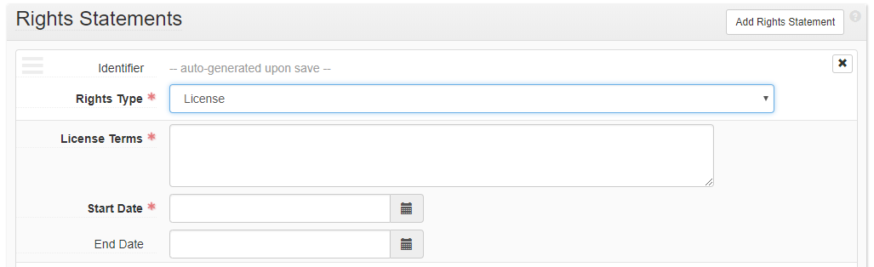
- License Terms(Required) - A statement (actual text snippet or summary) of the permissions granted in the license.
- Start Date(Required) - The date the rights statement went into effect.
- End Date - The date the rights statement ends.

Statute
When you select Rights Type "Statute", you will see the following fields:
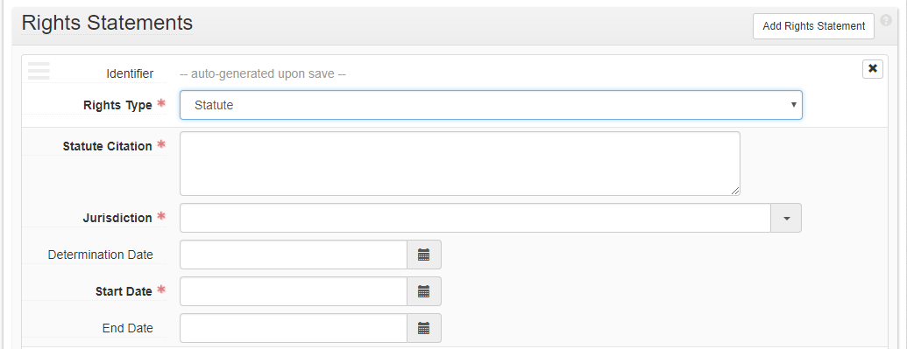
- Statute Citation(Required) - A citation, URI, or other reference to the statute related to this Rights Statement.
- Jurisdiction (Required) - The country or other political body enacting the statute. Conforms to ISO 3166.
- Determination Date - The date that the determination was made that the statute authorized the permission(s) noted.
- Start Date (Required)- The date the rights statement went into effect.
End Date - The date the rights statement ends.

Other
When you select Rights Type "Other", you will see the following fields: 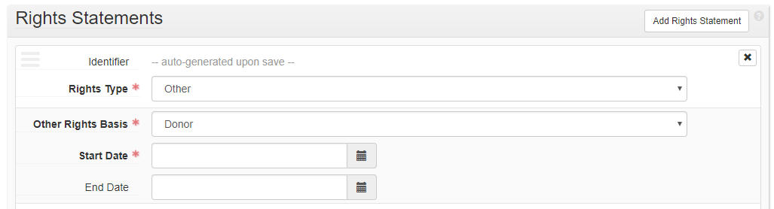
- Other Rights Basis(Required) - Rights Type of other rights statements that are not statutes, licenses, or copyright.
- Start Date(Required)- The date the rights statement went into effect.
- End Date - The date the rights statement ends.

Sub-Records for Rights Statements
There are four types of optional sub-records you can add to a rights statement: Notes, Acts, External Documents, and Agent Links. The fields in each of these types of sub-records are the same for all rights types. To add any of them to a rights statement, click the Add button at the top right of the particular sub-record type.

Notes Sub-Record
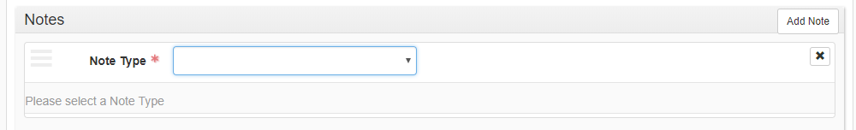
Once you specify a Note Type, additional fields will appear.
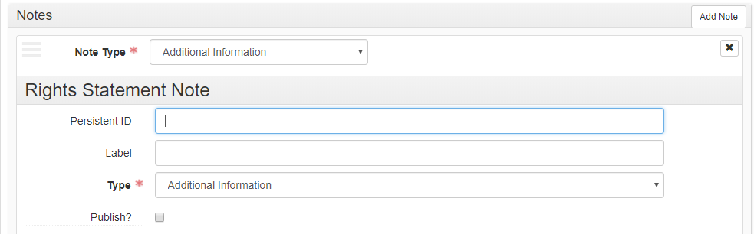

Acts Sub-Record
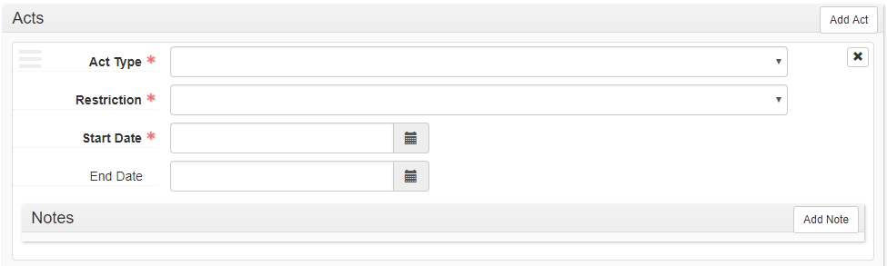
An Act sub-record has its own optional Notes sub-record, which works similarly to the Notes sub-record, but has different options.

External Documents Sub-Record

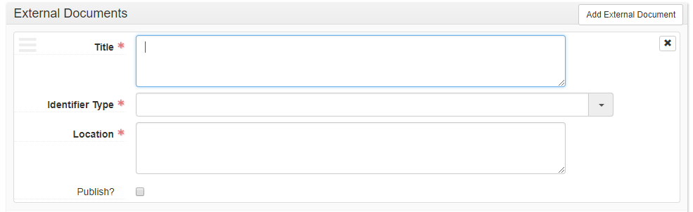
An External Documents sub-record in a rights statement is similar to an external document used elsewhere in the application, but includes a field for Identifier Type. This field is used to record to domain the external document belongs.

Agent Links Sub-Record
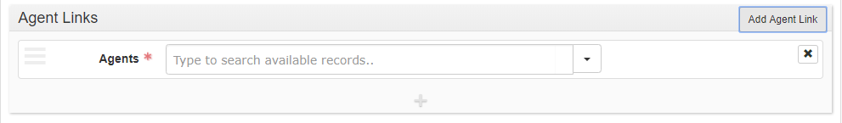
An Agent Links sub-record in a rights statement is identical to an agent link used elsewhere in the application.

To edit a Rights Statement sub-record
Navigate to the accession, resource, resource component, digital object, or digital object component in question and open in Edit mode. Select Rights Statement from the left sidebar menu and edit the content of the rights statement. Save the parent record when you are finished.

To remove a Rights Statement sub-record
- Find the Rights Statement sub-record that is to be deleted.
- Click on the X in the upper right corner of the Rights Statement sub-record link.
- Click on the Confirm Removal option to remove the Rights Statement sub-record, or on the Cancel option to retain the sub-record.
- Click on Save to save the context record with the Rights Statement or External Document link removed.

