I recommend that these guidelines are documented similar to how the enhanced container management functionality is documented. (See below.)
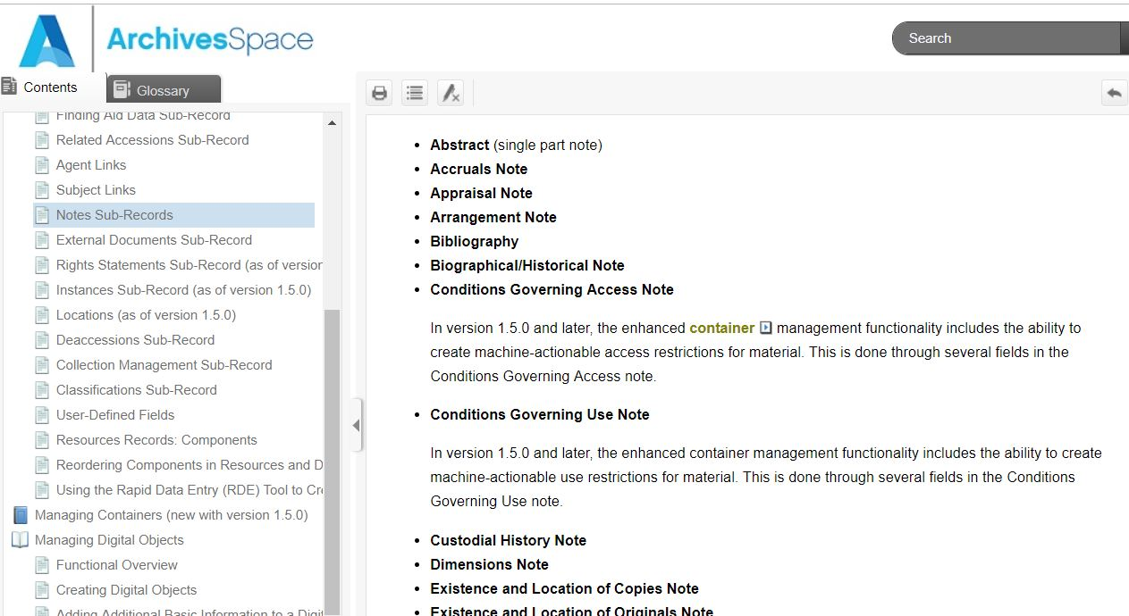

Embedding digital objects and hyperlinks in the content of notes
Digital images and links can be embedded and actuated in the Public User Interface by including the appropriate tag constructs in the Content text field of any given note.
To include an embedded image, use the <dao> tag with an href attribute with the value of the digital object URI and a show attribute with the value of “embed”. Other attributes may be included in the tag to describe and make the image more accessible. For example: <dao href="http://library.cshl.edu/images/archives/datura-workers-1927.jpg" actuate="onload" show="embed"></dao>. This may also be done using the <extptr> tag, if your institution still uses EAD 2002. (Note the extptr tag was deprecated in EAD3.)
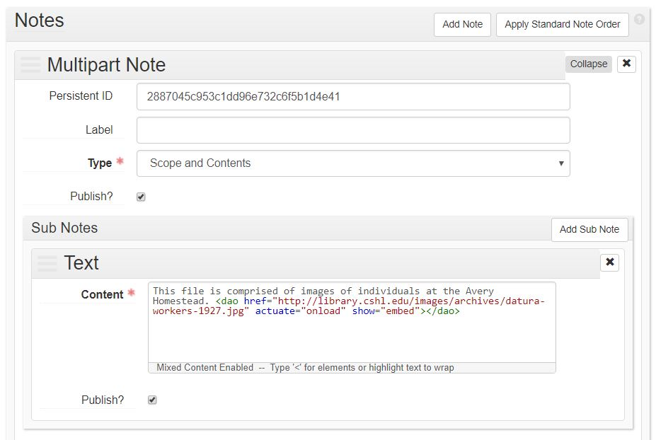
To include a link, use the <extref> tag with an href attribute for the URL to be hyperlinked. For example, <extref href="http://library.cshl.edu/personal-collections/amos-g-avery/collection-inventory">http://library.cshl.edu/personal-collections/amos-g-avery/collection-inventory</extref>.
